The PhD Origins of Finance Faculty
Abstract
We document the doctoral origins of finance faculty in U.S. finance departments. In our main sample, we find that graduates from top-ranked universities are disproportionately represented; for instance, nearly half of faculty come from universities with top 25 PhD programs, and many of these attended a top 5 university. Many of the faculty at top universities went to another (or the same) top university for their PhD. Among regional universities, we find evidence that it is common for departments to hire graduates from universities in the same geographical region.

Keywords: PhD, Finance Faculty, Doctoral Origins

1. Introduction
Where do finance faculty in the U.S. earn their PhDs? In this paper, we provide descriptive results on the doctoral origins of finance faculty. We focus on where finance faculty in these schools earn their doctoral degrees and where their PhD graduates place, conditional on being observed in our sample. To obtain faculty’s PhD origins, we use data from the 2019-2020 edition of the Finance, Insurance, and Real Estate (FIRE) Faculty Directory. After merging this finance faculty data with the UT-Dallas Business Research Rankings data, we find that higher-ranked finance programs produce a greater number of faculty than lower-ranked programs. For example, the top-ranked University of Chicago produces by far the largest number of finance professors (127), followed by Stanford University (87). Faculty from the top 25 PhD programs make up nearly half of faculty in our main sample, with many of these coming from the top 5 PhD programs. The top-ranked finance departments tend to hire from the top-ranked PhD programs. In our supplementary analyses, which consider schools that are typically less research-productive than those in our main sample, we find that faculty come primarily from PhD programs ranked 51 and below, with few coming from the top 10. We also find evidence that, at least among the regional universities, geography plays a large role—many of the faculty from a given geographic region come from a PhD program in that same region. In addition, we compare finance to several other fields and find overall that it ranks near the middle of the pack in terms of mobility, defined as the percentage of faculty in the top X universities who were trained at one of these same X universities (though this depends to some degree on which X we consider and which rankings we use).
Our study sheds some light on doctoral-to-professorial career mobility in finance academic markets. Previous studies have shown that the distribution of job opportunities is partially dependent on one’s personal network (which can be closely related to their academic origins) (Caplow and McGee, 1958; Berelson, 1960; Sawyer, 1981; Simon and Warner, 1992; McPherson et al., 2001; Kim et al., 2009). Depending on the cause(s) (which, unfortunately, our paper is not able to determine), lower mobility might indicate a lack of fairness, since universities may show a tendency to recruit candidates from top-ranked programs, who are not necessarily always the best candidates on the market. A lower degree of mobility might also represent close-mindedness in the hiring process and has the potential to hinder the amount of intellectual diversity in academic research. In addition, career mobility may have implications for how students are trained in these departments, both at the undergraduate and doctoral levels, as well as the types of ideas they bring with them to their positions after graduation. Therefore, it is important to have a better understanding of the current level of career mobility in finance academia.
Our results are also informative for finance PhD candidates entering the job market who might be attempting to secure a faculty position. Although having solid research and teaching backgrounds as well as a ready mind is crucial, a clear and comprehensive understanding of the common patterns and efficiencies of faculty hiring is also valuable.
What might explain faculty hiring patterns? There are several possible explanations. First is selection: top-ranked departments may hire individuals from top-ranked PhD programs if these individuals are also the most productive. They may be the most productive coming into the PhD program or may become the most productive through their university training. Second is networks. PhD students’ advisors may leverage their networks to give their students an advantage in the market. Third is PhD candidate preferences. For instance, the candidate may prefer to live in a particular part of the county. Fourth, top-ranked departments may have access to inside information about the candidates that are also from top-ranked programs. Fifth, individuals might feel like they would be more productive when working alongside (students of) their connections. Finally, if higher-ranked PhD programs produce more graduates, then we might expect to observe more of their students in professorships. We think that it is likely that all these explanations play at least some role.
Several studies explore the PhD origins of faculty in other fields, such as management, computer science, business, history, economics, English, and law (e.g., Bedeian et al., 2010; Clauset, Arbesman, and Larremore, 2015; Colander, 2015; Colander and Zhuo, 2015; Segall and Feldman, 2018; and Jones and Sloan, 2021). To the best of our knowledge, only two other papers have documented the PhD origins of finance faculty. Dyl and Hasselback (1998) focus on patterns of female faculty at the department and PhD production levels. Bair (2003)—the paper most similar to ours—looks at the hiring process in finance education for the top 10 schools. Our paper considers more than 600 departments and covers a more recent time period. In addition, we note a blog post by Ivo Welch in 2010 and updated in 2014 (Welch, 2014), which presents data and statistics on the PhD origins of faculty at 22 finance departments.
We also highlight related studies on the relationship between where finance faculty received their PhD and finance faculty hiring. Chan et al. (2009) examine the pedigree and placement effects of research productivity in finance and document that authors who are affiliated with elite institutions tend to be more productive, a result indicating that finance faculty’s PhD origins may be an indicator of their research productivity. Flagg et al. (2011) also examine the relationship between where new finance faculty got their PhDs and their research productivity. Their results indicate that publications or revisions in top-tier journals during their doctoral program are a better measure for their research potential than the school the attended. Similarly, Volkov et at. (2016) explore factors that determine finance PhD job market success and document that the ranking of their PhD program—along with publications, working papers, work experience, and the candidate’s network—are the major determinants. Hadlock and Pierce (2021) study finance faculty hiring and suggest that departments tend to hire finance PhD graduates with school connections to other recently hired faculty and are more likely to hire individuals with names that indicate a similar ethnic background to incumbent department members (see also Giuliano et al., 2009).

2. Data and Sample Definitions
2.1 Faculty Data
We use data on faculty from the 2019-2020 edition of the Finance, Insurance, and Real Estate (FIRE) Faculty Directory, collected by James R. Hasselback (2020). This directory includes faculty information for over 700 US universities; for simplicity, we refer to the faculty in this directory as finance faculty even though some focus more on other subjects, such as insurance and real estate. The data gathering process involved Hasselback collecting the list of faculty by going to department websites, and then contacting the departments to verify that the information was correct. The data are published on the web in PDF format; we extracted data on the faculty’s current department, title (Assistant, Associate, Full), highest degree earned, and university at which this degree was earned. We include faculty with highest degrees other than a PhD, such as a JD or an MBA. The directory includes all faculty members in a department, but we consider only those who we determine to be tenure track professors and classify them as assistant, associate, and full professors. To be conservative, we exclude deans and department chairs/heads as many of them are not in finance (for instance, if the chair is an economist in a joint finance and economics department).
Here, we note that a limitation of our analysis is that an individual must be a professor at one of the sample departments to appear in the dataset. Hence, the data exclude individuals who obtained finance PhDs and do not work in academia (or who work at a department not in our sample).
2.2 Rankings and Sample Construction
We rank and categorize both faculty departments and PhD programs. To do so we use rankings from the University of Texas at Dallas (UTD) to rank PhD programs (UTD Database, 2021). We use these same UTD rankings to rank all faculty departments that also appear in these rankings. For the remaining faculty departments, we use the US News & World Report (USNWR) University Rankings (USNWR, 2021). We describe both the UTD and USNWR rankings below.
2.2.1 UTD Rankings and Sample
The University of Texas at Dallas’ Naveen Jindal School of Management creates the Business School Research Rankings. This database tracks publications in leading business journals, scoring and ranking departments (or, in many cases, entities such as schools or colleges of business) based on faculty publications in a user-selected set of journals over a given period of time. We consider publications between 2000 and 2020 in what many consider to be the top three finance journals: The Journal of Finance, The Journal of Financial Economics, and The Review of Financial Studies. After excluding non-US and non-academic institutions, we obtain our UTD rankings.
There are 224 departments in the UTD rankings, which are shown in Appendix Table A.1. We merge these to the faculty departments from the FIRE data and successfully match 210 of them. We refer to the faculty from these 210 matched departments as the UTD sample, which is our main sample. There are many cases in which departments are tied; as such, we create a unique ID to distinguish tied schools in graphs. Departments not in the FIRE data do not have an ID, and this is indicated with an X in the table. The top five finance departments in our sample are University of Chicago, University of Pennsylvania, New York University, Harvard University, and Columbia University. We use these same UTD rankings to rank PhD programs.
It is important to point out that if a professor obtained a PhD at a university in a field other than finance, we still use the ranking corresponding to the finance program at this university and for simplicity refer to the PhD program as shorthand for the PhD university. For instance, if someone earned their PhD at Chicago’s Department of Economics instead of Chicago Booth, we consider them to have attended Chicago and use the PhD ranking for the Chicago’s finance program (Booth).
2.2.2 USNWR Rankings and Samples
In supplementary analyses, we consider the faculty departments that are not included in the UTD rankings. To do so, we use the USNWR undergraduate university rankings (USNWR, 2021). This has the advantage of broad coverage of institutions, but the disadvantage of the ranking not being specifically based on finance. This ranking system also does not group all schools together, but rather displays rankings within broad classifications of universities, including National Universities, Liberal Arts Colleges, Regional Universities (separately for North, South, Midwest, and West), and Regional Colleges (separately for North, South, Midwest, and West). We consider these groups but combine the Regional Colleges and a small number of universities that do not appear in one of the aforementioned groups into a sample called “Other.” Within each USNWR sample (other than Other), we rank the schools according to the USNWR ranking within the respective broad classification. To summarize, our main sample is the UTD sample, and we also create the National Universities, Liberal Arts Colleges, Regional Universities (separately for North, South, Midwest, and West), and Other samples. If a university appears both in UTD and in one of the USNWR samples, we consider it only in the UTD sample.
2.3 Measure for Career Mobility
In our analysis that compares finance to other disciplines, we construct a measure of PhD career mobility following Chetty et al. (2014). Chetty et al. (2014) measure intergenerational mobility in the U.S. using “the degree to which a child’s social and economic opportunities depend on his parents’ income or social status.” Specifically, they use three statistical measures of absolute mobility, all of which measure the probability that one will end up in the top X% income distribution if he/she was born in a family in the bottom X% of income distribution. We adopt a somewhat similar design and use the metric of what fraction of faculty at the top X universities got their PhDs from one of these same X universities, where X is 5, 10, 25, or 50. Our career mobility measure ranges from 0 to 1, with 0 representing full mobility and 1 representing no mobility. We then compare career mobility across disciplines including finance, business, computer science, history, law, and economics.
2.4 Characteristics of Samples
Table 1 displays the characteristics of the various samples. Only 4% of the UTD sample is missing PhD. Appendix Figure A.1 displays the percent missing by school; most schools do not have any faculty with missing PhD information. For most of the other samples, there is also a low percentage of observations with missing information on PhD. Unless otherwise noted, we exclude these individuals from future analyses, including the rest of the columns in Table 1.
The UTD sample contains 210 departments with 2,389 faculty and 11.4 faculty per department (Table 1). This is a much higher number of faculty per department than the other samples, as well as a much lower number of faculty per sample. The mean, median, minimum, and maximum rank of schools in a particular sample corresponds to the rank specific to the sample. Because many of the national universities are already included in the UTD sample, the national university sample includes relatively low-ranked schools. Our USNWR samples contain only a fraction of the schools in the USNWR rankings for the respective samples.
3. Results
We first present results for the UTD sample, then for the USNWR samples.
3.1 UTD Sample
We first consider PhD programs and how many faculty in the UTD sample they produce. Figure 1 displays the number of tenure-track faculty produced by each finance PhD program, with programs ordered according to ID. There is a clear negative relationship between number of professors produced and the ranking of the schools, with the top-ranked programs producing disproportionately many faculty members and lower-ranked programs producing disproportionately few. Table 2 shows the number by program. Chicago produces by far the most (127), followed by Stanford (87), MIT (82), Pennsylvania (80), and Harvard (78). Of note is that, while UTD rank is correlated with the position in Table 2, it is far from a 1:1 relationship. Stanford and MIT, which appear second and third in the table, are ranked 7th and 9th in the UTD rankings. UCLA, Columbia, and Duke, ranked 6th, 5th, and 8th in UTD, appear much lower. Appendix Figure A.3 shows that the average rank of faculty department a PhD program’s graduates teach at (conditional on being faculty in the UTD sample) is higher the higher the PhD program is ranked.
Next, we focus on the faculty department, grouped by broad categories: faculty departments ranked 1-5, 6-10, 11-25, 26-50, 51-100, 101-224+ (which includes US institutions not in the UTD rankings), and International. Figure 2 shows flows from PhD programs (on the left; grouped according to the same categories) to faculty departments (on the right). Focusing on the height of the groups on the left side, just under half (49%) of all PhDs come from programs ranked in the top 25, with the remainder largely consisting of programs ranked 26-100. Few come from U.S. departments ranked higher (or not in the rankings) than 100 or from international programs. Among faculty from the top 25, 33% come from the top 5 ranked programs. In addition, it is rare for PhDs from a given category to teach in a faculty department category ranked higher, particularly for PhD programs ranked 11 and below. Appendix Figure A.4 shows that in general, only a small fraction of faculty teach at a department ranked higher than their PhD program.
Within a given department ranking category on the right, the relative height of the flows of Figure 2 indicates the percentage of PhDs from a given PhD grouping. This is also indicated in the transition matrix shown in Table 3. 42% (71%) of faculty at top 5 institutions got their PhD at one of the top 5 (10) ranked PhD programs. This pattern is nearly identical for faculty departments ranked 6-10. The percentage of PhDs from the top 5 and 6-10 ranked programs is monotonically decreasing across faculty department category (across rows 1 and 2). Conversely, the percentage of PhDs from PhD programs ranked 26-50, 51-100, and 101-224+ is nearly monotonically decreasing across faculty department category (across columns when comparing rows 4, 5, and 6). The 11-25 category follows an inverse U-shaped pattern (across row 3). Faculty with international PhDs are spread relatively evenly across category.
We proceed to consider individual departments. Figure 3 shows—for each department in the UTD sample (x axis)—the average rank of the PhD program the department’s faculty came from (conditional on their PhD being from a school in the UTD rankings). There is an upward-sloping linear relationship between average PhD rank and department ID. All of the top-ranked departments consist of faculty from, on average, top-ranked programs. Nearly all of the departments ranked below 100 have faculty that come from PhD programs on average ranked below 50. Appendix Figure A.5 shows the percentage of department faculty that come from a given tier of PhD program. This confirms that higher-ranked faculty departments are more likely to hire faculty from higher-ranked PhD programs.
How has the concentration changed over time? While imperfect, we can split into Assistant and Full professors. Figure 4 shows that up until around the 100th ranked faculty department, assistant professors come from higher-ranked PhD programs than do full professors. Though the confidence intervals overlap, this is a small amount of evidence that faculty come from higher-ranked programs now compared to the past.
Figure 5 shows the composition of faculty by PhD program group, where each faculty department is a stacked bar. This demonstrates that while the broad patterns demonstrated in earlier results hold, there is heterogeneity at the department level. For instance, some departments have higher concentrations of faculty from the top 5 and 10 programs than do others very similar in rank. Appendix Figures A.7 and A.8 zoom in on Figure 5 for the top 100 departments.
We further explore the top 10 ranked departments in Figure 6. Now, instead of the stacked bars including the PhD program categories defined above, the bars now represent the top 10 PhD programs, with additional bars for all other U.S. programs and for international programs. We find a very heavy concentration of hiring from among the top programs: at least half of the faculty at each of the top 10 departments received their PhD from one of these same PhD programs. Chicago PhDs are well-represented across each department (with the exception of Stanford). There is a good deal of variation in the fraction of faculty from U.S. departments outside the top 10 (and not international), with only 4% at Harvard to 47% at Michigan. Harvard has the highest rate of internal recruitment (which includes hiring professors who have started their careers elsewhere), with a full 42% of its faculty coming from itself. In contrast, Pennsylvania, Columbia, and Michigan are the least inclined to engage in this practice. We highlight instances where there is a heavy concentration of faculty in a department from a given PhD program in Appendix Table A.2. The top two instances (among departments with at least 7 faculty) are Harvard to Harvard and Harvard to Yale.
3.2 USNWR Samples
Figure 7 shows the flows from the tiers of PhD program to each of the USNWR samples. Recall that departments that appear in the UTD analysis are not included in the USNWR samples. Compared to the analogous Figure 2 (which is for the UTD sample), few faculty come from PhD programs ranked in the top 25. Among the top 5 PhD programs, many go to national universities and regional universities in the north. The bulk of faculty in these USNWR samples come from PhD programs ranked 51 and higher. Appendix Figure A.9 shows that there is much less variation in the average rank of PhD program across the ranking within a given USNWR sample than there was in the UTD sample (Figure 3).
From which PhD programs do the faculty in the USNWR sample come from? Table 4 shows the results; note that the universities in this table refer to the university at which the faculty of the particular sample received their PhD and not the departments in these samples themselves. Among national universities (which do not appear in the UTD rankings), universities in the south dominate: PhD graduates from Florida State, Alabama, Mississippi, Florida Atlantic, and Georgia make up the top five. There are other regional patterns visible: most of the top-producing PhD programs are physically located in the region of the sample. For instance, all of the listed PhD programs for regional universities in the south are also in the south. To explore this further, Figure 8 plots the locations of the PhD programs by regional university sample, with the size (radius) of the dot corresponding to the number of faculty from that program. The red square indicates the weighted average location. We find geographic concentration: on average the PhD programs among faculty at western departments are located farthest to the west, those in southern departments are located farthest to the south, and those in northern departments are located farthest to the northeast.
4. Comparison to other Fields
So far, we have documented the PhD origins of finance faculty in various ways, and the results in general indicate that departments tend to hire PhD candidates from programs with higher (or similar) rankings. However, it is difficult to judge whether the degree of career mobility in finance is low or high without comparing to other disciplines. In this section, we compare finance to business, computer science, history (Clauset, Arbesman, and Larremore, 2015); law (Segall and Feldman, 2018); and economics (Jones and Sloan, 2021). In addition to considering only a relatively small number of other disciplines, this exercise is imperfect for reasons including differences in the year of data and sample selection criteria across datasets. For example, the law data do not contain information on the terminal degree university for faculty with a degree other than a J.D., while the finance and economics data do include those whose terminal degree is not a Ph.D. (and we do not attempt to exclude those with non-doctoral degrees for these fields). In including law, we note the caveat that this discipline is different for several reasons, including being a professional degree, having a shorter time to degree, and often having larger class sizes. As mentioned above, we use the metric of “What fraction of faculty at the top X universities got their PhDs from one of these same X universities?”, where X is 5, 10, 25, or 50; possible values range from 0 (0%) to 1 (100%), where the latter corresponds to no mobility whatsoever.
Table 5 shows the results. In Panel A, we rank universities using UTD rankings for finance (focusing only on the “UTD sample”) and USNWR graduate field ranking for the other fields. In the first column, we consider the fraction of the top 5 departments that have faculty from these same top 5 programs. Law has by far the least mobility (highest number in the table), while history and finance have the most mobility. Economics, computer science, and business fall in between. In the remaining columns (top 10, top 25, and top 50), finance appears near the middle. Law continues to have the least mobility across all remaining columns, with economics following. Law is perhaps more exceptional than it appears because a very high percentage of faculty come from just two schools: Yale and Harvard. 64% of faculty at Yale and Harvard come from Yale and Harvard; and 70%, 57%, and 51% of faculty at the top 5, 10, and 25 departments come from Yale and Harvard.
We next construct our own rankings based on the number of PhDs produced. This gives a different perspective on mobility in the event that a field’s UTD or USNWR ranking does not align well with how many PhDs a program produces. This is the case with finance. For instance, Table 2 shows that for finance (and across the entire “UTD sample”), Stanford and MIT produce the second and third most PhDs, but their UTD rankings are 7 and 9. In Panel B of Table 5, we re-rank based on how many PhDs a program produces who are teaching at one of the top 25 ranked departments. This makes relatively little difference for most fields, but makes a large difference for finance. With these new rankings, finance ranks as having the third (or tied for second) least mobility among fields.
The above results include all faculty regardless of where they received their PhD, including internationally. In contrast, we now focus only on the faculty who received their PhD at a top 100-ranked program (in the US), which also excludes those with international PhDs. Panel C of Table 5 is analogous to Panel A, and Panel D is analogous to Panel B. Because we shrink the denominator, all fractions are larger, with increases higher in some fields (like history) than in others (like law). However, the relative ordering across fields is similar in many, but not all cases. Overall, among professors with a U.S. Ph.D. (in the top 100), we observe that across all fields it is rare for a professor to teach at a department ranked higher than his or her Ph.D. program, particularly when we consider the top 25 and top 50 departments. We also find that across the different columns and panels finance broadly ranks roughly in the middle of the fields we consider in this table in terms of mobility.
In summary, finance’s standing among the other fields we consider depends on the way in which we rank it, but it is broadly in the middle of the pack, at least compared to the small number of disciplines we consider here.
5. Conclusion
In this paper we provide descriptive evidence of how finance departments across the nation hire. In our main (UTD) sample, we document that higher-ranked PhD programs produce more PhDs and place them at higher-ranked departments. Excluding international PhDs, more than half of faculty attended a university with a top 25 PhD program. Of these, many attended a top 5. Higher-ranked departments draw from higher-ranked PhD programs. In our supplementary (USNWR) samples, which tend to be less research intensive than departments in our main (UTD) sample, most faculty came from a PhD program ranked below 50th. We explore geography among regional universities and find that it plays a role—these institutions often hire professors who attended a university in the same region. We finally show that among the several other fields we consider (and depending to some degree on the particular statistic and ranking method we are considering), finance has more mobility than some fields, but less than others.

Acknowledgements
Much of the work was completed with Xiong was a graduate student at Mississippi State University. We would especially like to thank James Hasselback for creating the main data we use, and for useful feedback. We would also like to thank Aaron Clauset for making his and his coauthors’ (Samuel Arbesman and Daniel Larremore) data on faculty hiring networks publicly available on his website, as well as Adam Feldman for providing his and his coauthor’s (Eric Segall) data on law faculty to us. We would finally like to thank Ryan Israelsen and Arielle Sloan for useful feedback.

References
Bair, J. H. (2003). Hiring practices in finance education: Linkages among top‐ranked graduate programs. American Journal of Economics and Sociology, 62(2), 429-433.
Bedeian, A. G., Cavazos, D. E., Hunt, J. G., & Jauch, L. R. (2010). Doctoral degree prestige and the academic marketplace: A study of career mobility within the management discipline. Academy of Management Learning & Education, 9(1), 11-25.
Berelson, B., 1960. Graduate education in the United States. New York: McGraw-Hill.
Caplow, T. and McGee, R.J., 1956. The academic marketplace. New York: Basic.
Chan, K.C., Chen, C.R. and Fung, H.G., 2009. Pedigree or placement? An analysis of research productivity in finance. Financial Review, 44(1), pp.87-111.
Chetty, R., Hendren, N., Kline, P., & Saez, E. (2014). Where is the land of opportunity? The geography of intergenerational mobility in the United States. The Quarterly Journal of Economics, 129(4), 1553-1623.
Clauset, A., Arbesman, S., & Larremore, D. B. (2015). Systematic inequality and hierarchy in faculty hiring networks. Science Advances, 1(1), e1400005.
Colander, D. (2015). Intellectual Incest on the Charles: Why Economists are a little bit off. Eastern Economic Journal, 41(2), 155-159.
Colander, D., & Zhuo, D. (2015). Where do PhDs in English get jobs? An economist’s view of the English PhD market. Pedagogy: Critical Approaches to Teaching Literature, Language, Composition, and Culture, 15(1), 139-156.
Dyl, E. A., & Hasselback, J. R. (1998). The hiring of women in finance academia. Journal of Financial Education, 1-7.
Flagg, D., Gilley, O.W. and Park, J.C., 2011. Job market signaling: what drives the productivity of finance Ph. Ds? Financial Management, 40(2), pp.483-513.
Giuliano, L., Levine, D.I. and Leonard, J., 2009. Manager race and the race of new hires. Journal of Labor Economics, 27(4), pp.589-631.
Hadlock, C.J. and Pierce, J.R., 2021. Hiring your friends: Evidence from the market for financial economists. ILR Review, 74(4), pp.977-1007.
Hasselback, J.R. (2020). Finance, Insurance, and Real Estate (FIRE) Faculty Directory. http://www.jrhasselback.com/FacDir.html
Jones, T. R., & Sloan, A. (2020). Staying at the Top: The Ph. D. Origins of Economics Faculty. EdWorkingPaper: 20-324. Annenberg Institute.
Kim, E.H., Morse, A. and Zingales, L., 2009. Are elite universities losing their competitive edge? Journal of Financial Economics, 93(3), pp.353-381.
McPherson, M., Smith-Lovin, L. and Cook, J.M., 2001. Birds of a feather: Homophily in social networks. Annual Review of Sociology, pp.415-444.
Oyer, P., 2006. Initial labor market conditions and long-term outcomes for economists. Journal of Economic Perspectives, 20(3), pp.143-160.
Oyer, P., 2008. Ability and employer learning: Evidence from the economist labor market. Journal of the Japanese and International Economies, 22(2), pp.268-289.
Sawyer, D.O., 1981. Institutional stratification and career mobility in academic markets. Sociology of Education, pp.85-97.
Segall, E. J., & Feldman, A. (2018). The Elite Teaching the Elite: Who Gets Hired by the Top Law Schools? Journal of Legal Education., 68, 614.
Simon, C.J. and Warner, J.T., 1992. Matchmaker, matchmaker: The effect of old boy networks on job match quality, earnings, and tenure. Journal of Labor Economics, 10(3), pp.306-330.
U.S. Department of Education (2019). National Center for Education Statistics, Integrated Postsecondary Education Data System (IPEDS), 2019.
USNWR (2009). U.S. News & World Report History Graduate School Rankings. Ranked in 2009.
USNWR (2010). U.S. News & World Report Computer Science Graduate School Rankings. Ranked in 2010.
USNWR (2011a). U.S. News & World Report Business Graduate School Rankings. Ranked in 2011.
USNWR (2011b). U.S. News & World Report English Graduate School Rankings. Ranked in 2011.
USNWR (2017). U.S. News & World Report Economics Graduate School Rankings. Ranked in 2017.
USNWR (2018). U.S. News & World Report Law Graduate School Rankings. Ranked in 2018.
USNWR (2021) U.S. News & World Report Best Colleges Rankings. (2021). https://www.usnews.com/best-colleges
UTD Database (2021). The UTD top 100 business school research rankings. https://jindal.utdallas.edu/the-utd-top-100-business-school-research-rankings/
Volkov, N., Chira, I. and Premti, A., 2016. Who is successful on the finance Ph. D. job market? Journal of Corporate Finance, 37, pp.109-131.
Welch, Ivo (2014). How Good Were Phd Networks in Finance? https://www.ivo-welch.info/meta-fin/2014/04/07/phdnetworks.html
Figures and Tables

Figure 1: Number of Faculty (in Sample) Produced, by PhD Program
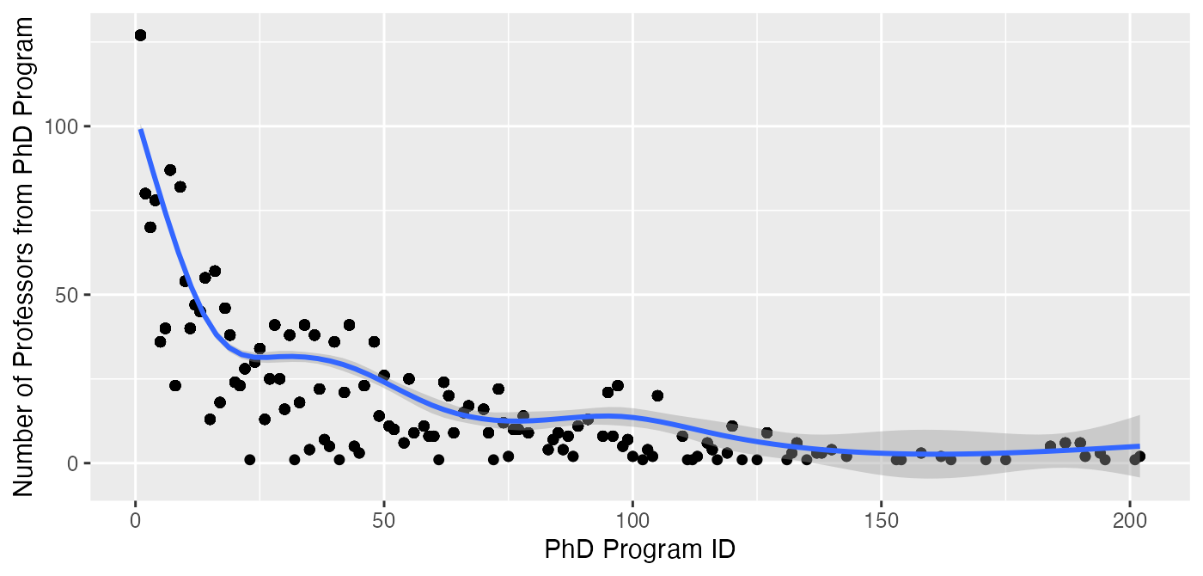
Notes: This figure displays the number of faculty in the UTD sample produced by PhD program, which is ordered according to ID (see Appendix Table A.1). In other words, this displays how many graduates of a given PhD program are now faculty members at departments in the sample. PhD programs are limited to those in Appendix Table A.1.

Figure 2: Flows from PhD Programs (Left) to Departments (Right), by Category
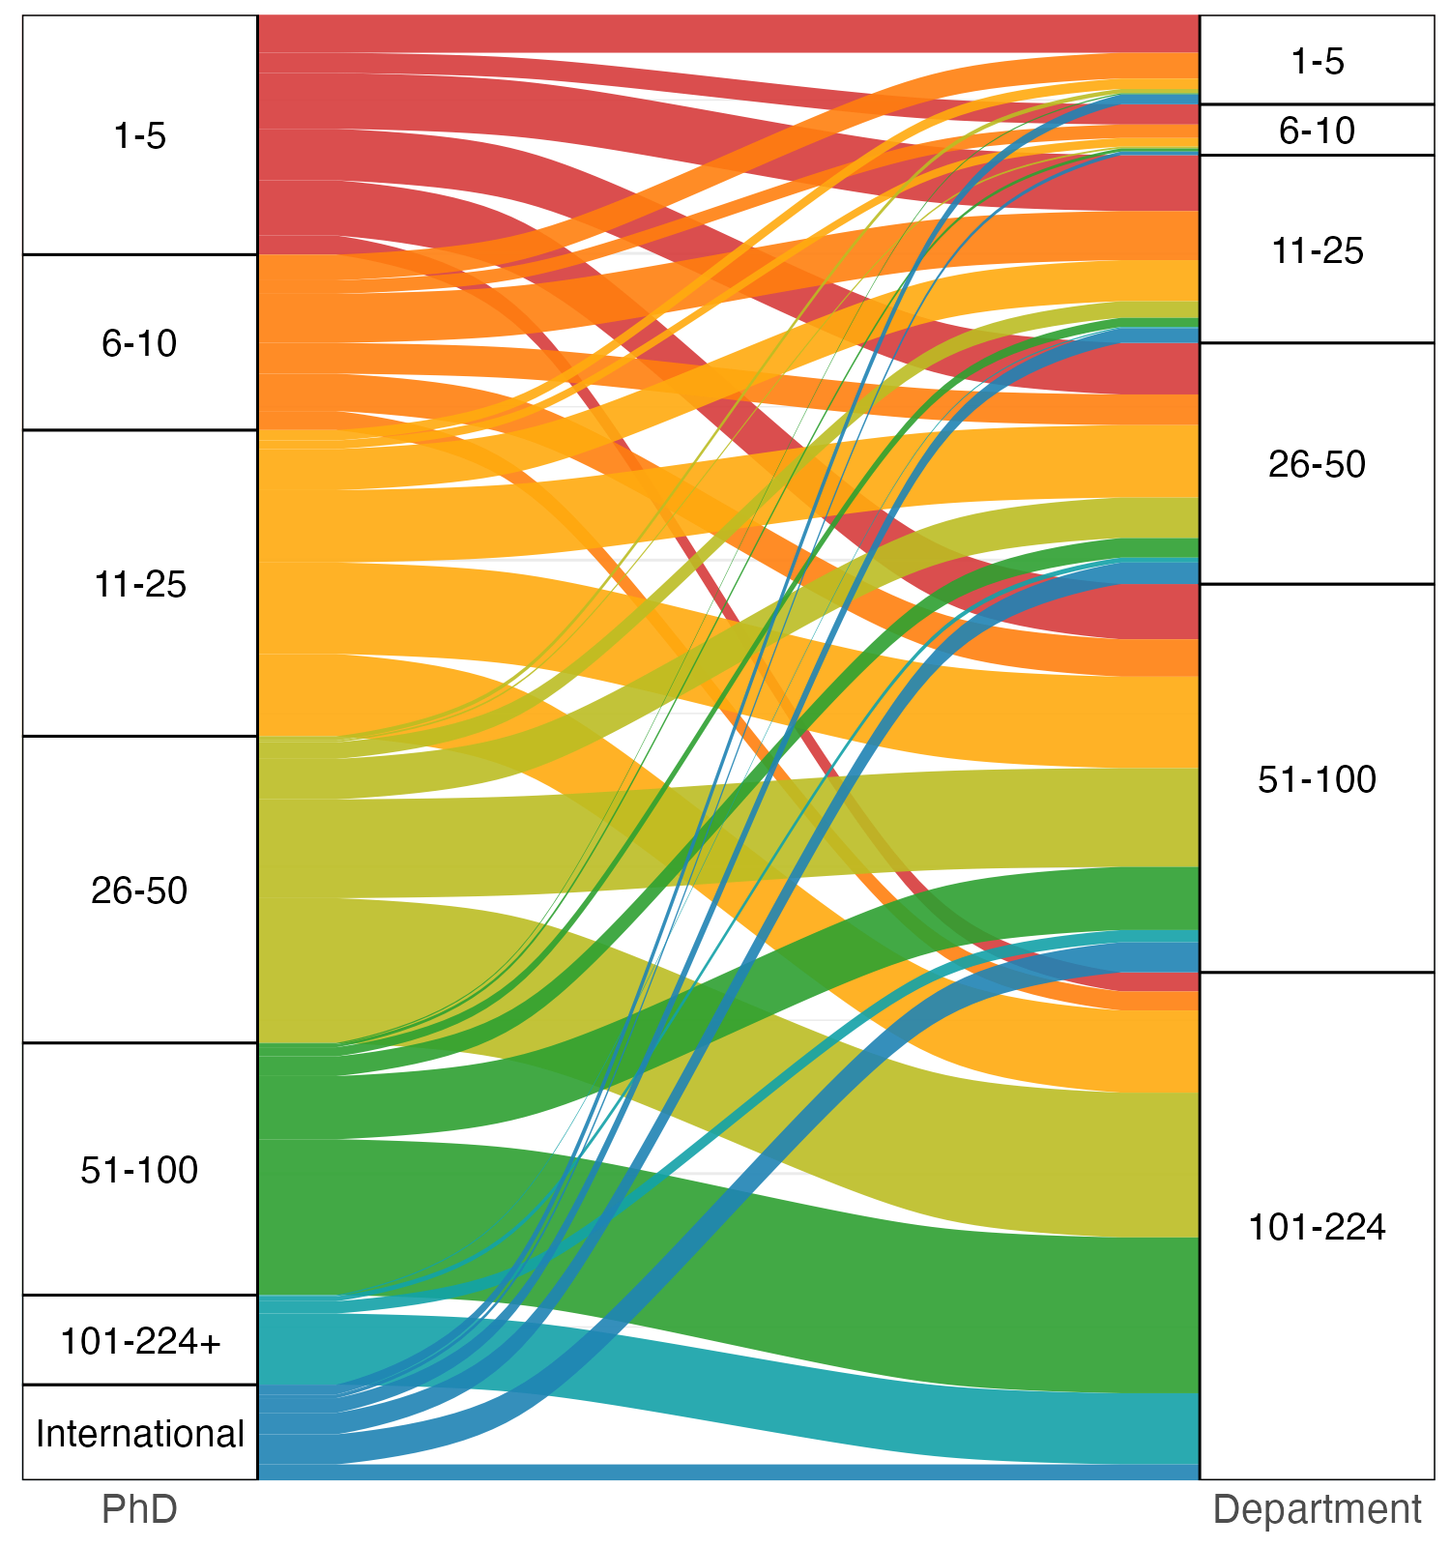
Notes: This Sankey diagram shows flows from PhD programs (left) to departments (right) in the UTD sample. The width of the flow represents the number of individuals going from one group to another. The PhD category 101-224+ includes a small number of US observations that are not in the UTD rankings.

Figure 3: Average Rank of PhD Programs of a Department’s Faculty, by Department
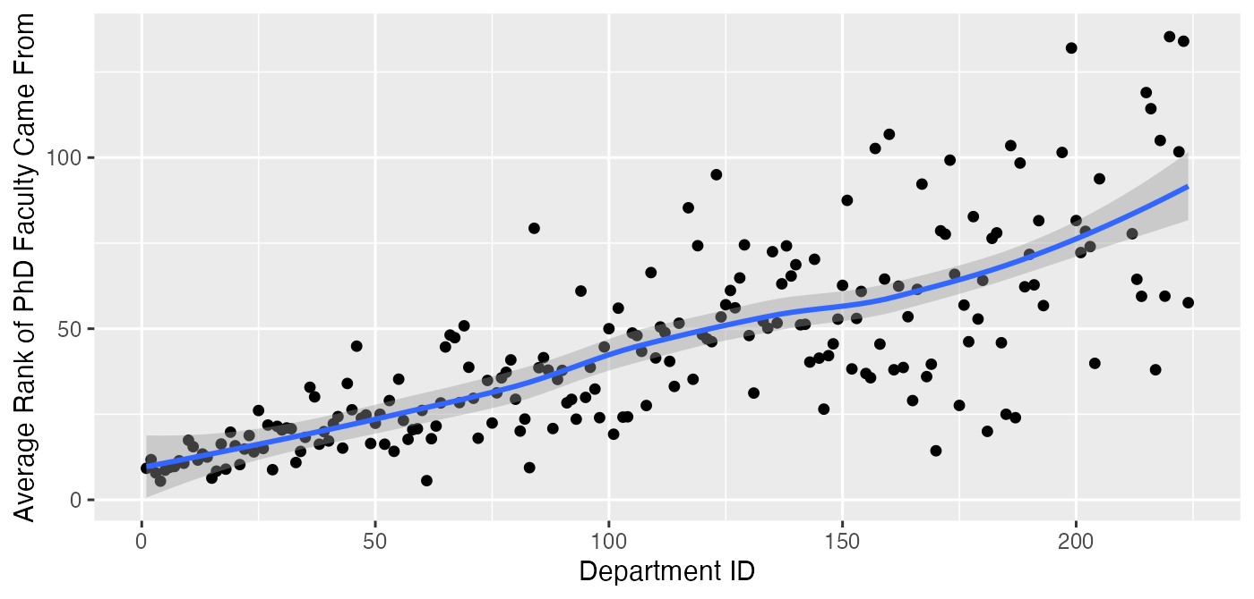
Notes: This figure displays, for a given department in the UTD sample, the average rank of the PhD programs faculty members attended. Departments are ordered according to ID (see Appendix Table A.1). It is restricted to those who went to ranked PhD programs.

Figure 4: Average Rank of PhD Programs of a Department’s Faculty, by Department, by Rank
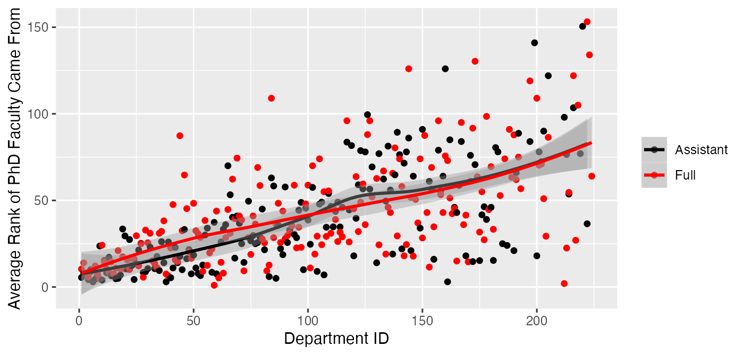
Notes: This figure displays, for a given department in the UTD sample, the average rank of the PhD programs faculty members attended. It is split by Assistant and Full professors. Departments are ordered according to ID (see Appendix Table A.1). It is restricted to those who went to ranked PhD programs.

Figure 5: % of Dpt. Faculty from Different Tiers of PhD Program, by Department
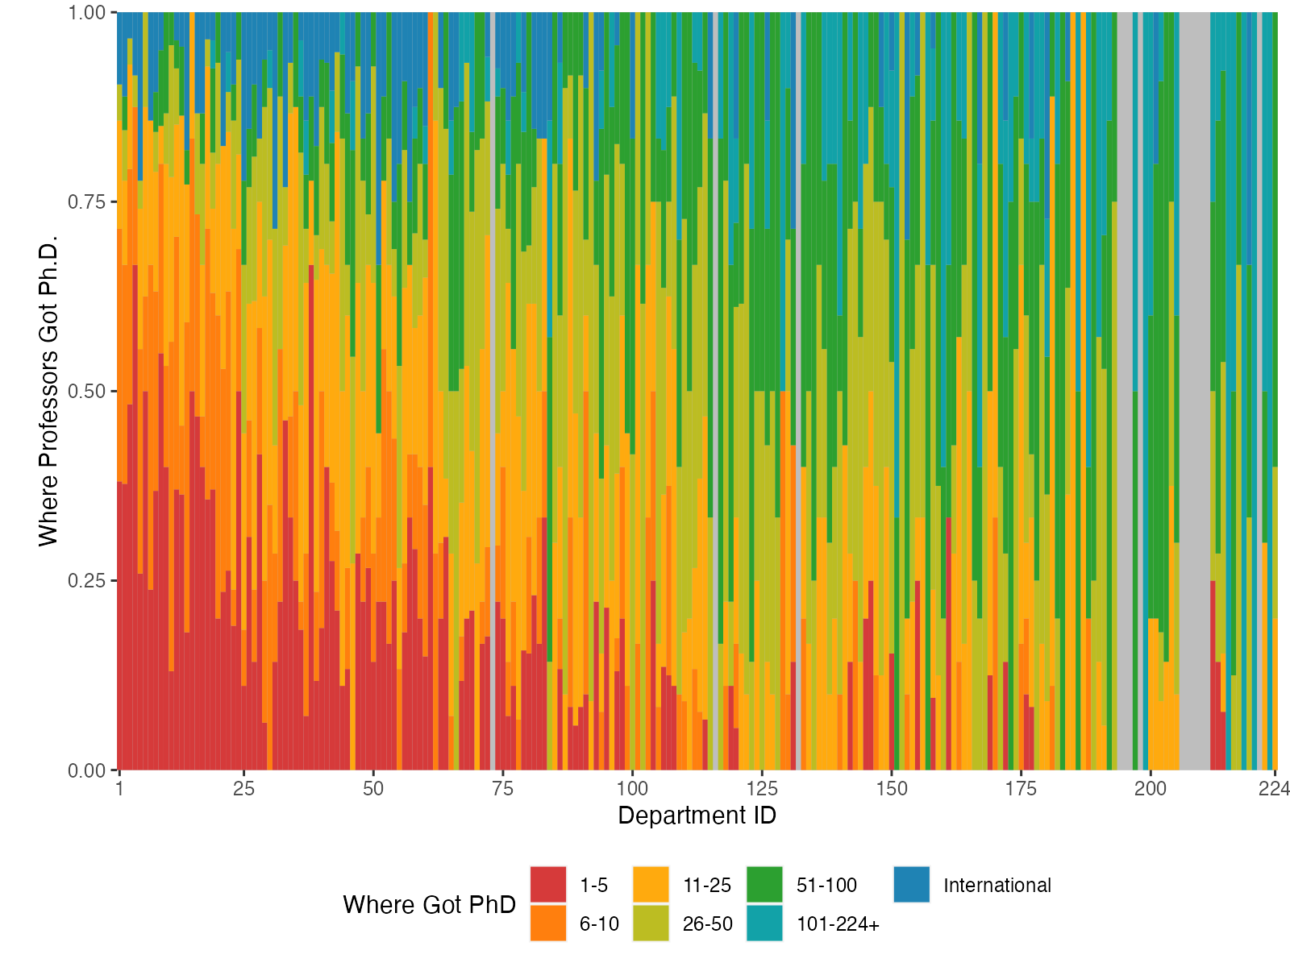
Notes: This bar chart displays the percentage of a department’s faculty that came from groupings of PhD program rankings. Only the UTD sample is considered. Each column is a department, and the colorings of the columns represent the percentage of faculty that come from the particular PhD program group. Departments are ordered according to ID (see Appendix Table A.1). The PhD category 101-224+ includes a small number of US observations that are not in the UTD rankings.

Figure 6: PhDs of Faculty of Top Ten Departments
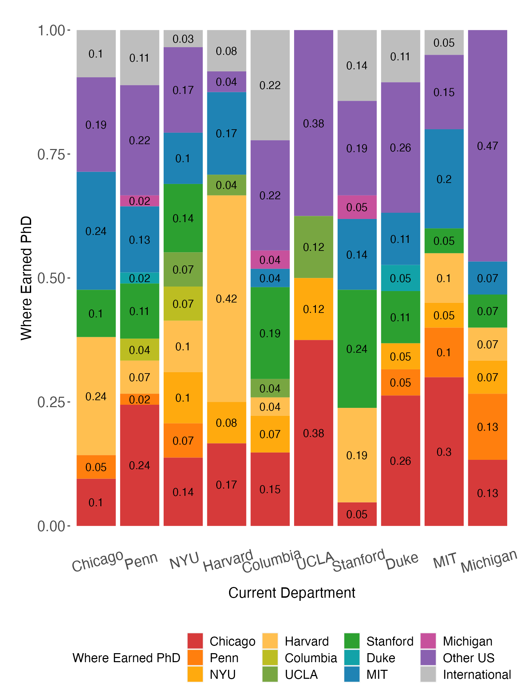
Notes: This figure displays the percentage of a department’s faculty that came from groupings of PhD program rankings. Each column is a department, and the colorings of the columns represent the percentage of faculty that come from the particular PhD program.

Figure 7: Flows from PhD Programs (Left) to Departments (Right), by USNWR Sample
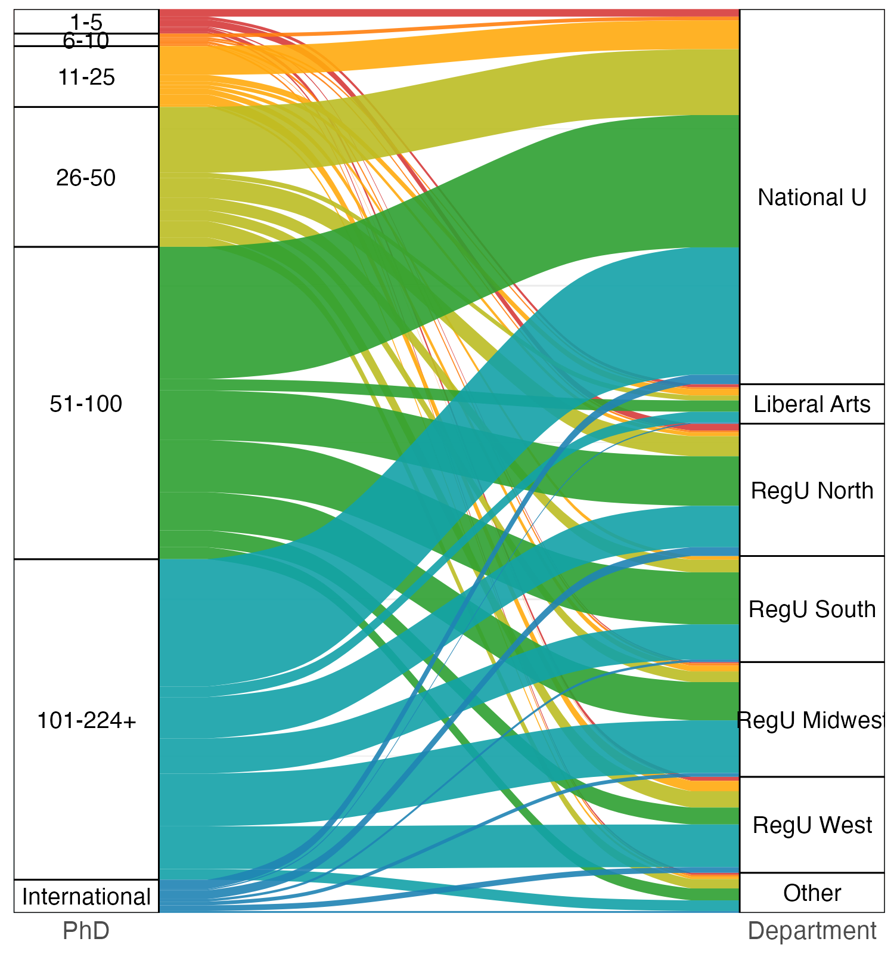
Notes: This Sankey diagram shows flows from PhD programs (left) to departments within the different USNWR samples (right). Faculty from the UTD sample are not included. The width of the flow represents the number of individuals going from one group to another. The PhD category 101-224+ includes a small number of US observations that are not in the UTD rankings.

Figure 8: PhD Origins for Regional Universities
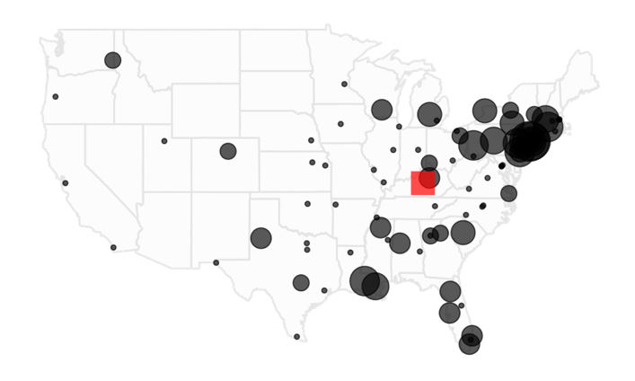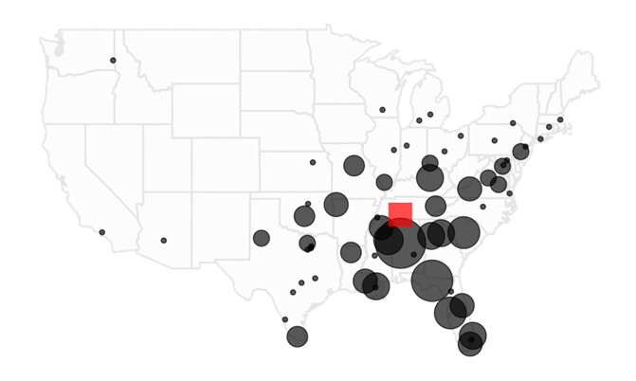
- North (B) South

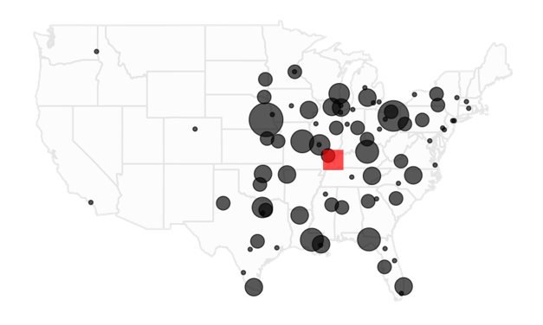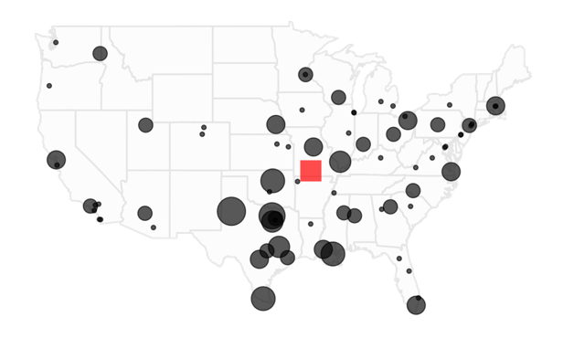
(C) Midwest (D) West
Notes: This graph shows the locations of the PhD schools attended by faculty at regional universities in the south (Panel A), north (B), midwest (C), and west (D). Dot size represents the number of faculty (where the radius is doubled with twice as many faculty). The red square is the weighted centroid (computed by taking the weighted mean of the latitudes and the weighted mean of the longitudes, not explicitly factoring in earth curvature). PhD origins from Hawaii are excluded from the map, but included in the centroid calculation. A university that no longer exists is excluded from the map and centroid calculation.

Table 1: Summary Statistics

Sample | N Schools | N Faculty | Faculty per School | Mean Rank | Median Rank | Min Rank | Max Rank | Missing PhD
UTD | 210 | 2389 | 11.4 | 106.6 | 106.5 | 1 | 222 | 0.04
National Univ. | 133 | 598 | 4.5 | 242.3 | 272 | 30 | 298 | 0.08
Liberal Arts | 36 | 63 | 1.8 | 101.9 | 112.5 | 9 | 171 | 0.03
Reg. Univ. North | 59 | 211 | 3.6 | 63 | 59 | 1 | 136 | 0.07
Reg. Univ. South | 54 | 169 | 3.1 | 49.9 | 46 | 1 | 103 | 0.12
Reg. Univ. Midwest | 65 | 183 | 2.8 | 60.8 | 59 | 1 | NA | 0.09
Reg. Univ. West | 52 | 153 | 2.9 | 53.5 | 52 | 1 | NA | 0.15
Other | 31 | 64 | 2.1 | NA | NA | NA | NA | 0.22

Notes: This table displays summary statistics for the different samples. UTD refers to the schools that appear in the UTD rankings. The remaining samples are based on classification in USNWR. N Schools is the number of schools in the rankings. Faculty per School is the average number of faculty per school. Mean, Median, Min, and Max Rank refer to the school’s ranking in the UTD rankings for the UTD sample and in the USNWR rankings for the remaining schools. They are indicated as NA for the Other sample as this sample includes schools from different department categories. Missing PhD is the fraction of faculty that are missing PhD. All other columns are conditional on observing PhD.

Table 2: PhD Programs with Highest Number of Graduates in UTD Sample
PhD | N | UTD Rank
University of Chicago | 127 | 1
Stanford University | 87 | 7
Massachusetts Inst of Tech | 82 | 9
University of Pennsylvania | 80 | 2
Harvard University | 78 | 4
New York University | 70 | 3
Ohio State University | 57 | 16
U of California-Berkeley | 55 | 14
University of Michigan | 54 | 10
Northwestern University | 47 | 12
University of Illinois | 46 | 18
University of North Carolina | 45 | 13
University of Florida | 41 | 34
University of Georgia | 41 | 43
University of Rochester | 41 | 28
Univ of Calif, Los Angeles | 40 | 6
Univ of Texas at Austin | 40 | 11
Boston College | 38 | 19
Penn State University | 38 | 36
Purdue University | 38 | 31
Columbia University | 36 | 5
Georgia State University | 36 | 48
Univ of Wisconsin-Madison | 36 | 40
Indiana University | 34 | 25
Yale University | 30 | 24
University of Washington | 28 | 22
Texas A&M University | 26 | 50
Arizona State University | 25 | 27
University of Iowa | 25 | 55
University of Minnesota | 25 | 29
Cornell University | 24 | 20
University of Pittsburgh | 24 | 62
Duke University | 23 | 8
Florida State University | 23 | 97
University of Arizona | 23 | 46
Washington University | 23 | 21
Michigan State University | 22 | 37
Princeton University | 22 | 73
CUNY-Baruch College | 21 | 42
University of Alabama | 21 | 95
Texas Tech University | 20 | 105
Univ of South Carolina | 20 | 63
Carnegie Mellon University | 18 | 33
University of Maryland | 18 | 17
Virginia Poly Inst & St Un | 17 | 67
Louisiana State University | 16 | 70
University of Utah | 16 | 30
U of Missouri at Columbia | 15 | 66
University of Houston | 14 | 49
University of Kentucky | 14 | 78
Emory University | 13 | 26
Univ of Southern California | 13 | 15
University of Massachusetts | 13 | 91

Notes: This table displays the number of faculty produced by PhD program who are faculty at a department in the UTD sample. Programs that generated fewer than 13 faculty are not considered. International PhDs are not considered.

Table 3: Transition Matrix, UTD Sample
Department Tier
PhD Tier | 1-5 | 6-10 | 11-25 | 26-50 | 51-100 | 101-224
1-5 | 0.42 | 0.40 | 0.30 | 0.21 | 0.14 | 0.04
6-10 | 0.29 | 0.27 | 0.26 | 0.13 | 0.10 | 0.04
11-25 | 0.12 | 0.17 | 0.22 | 0.30 | 0.24 | 0.16
26-50 | 0.05 | 0.04 | 0.09 | 0.17 | 0.25 | 0.29
51-100 | 0.01 | 0.06 | 0.05 | 0.08 | 0.16 | 0.31
101-224+ |  |  | 0.01 | 0.02 | 0.03 | 0.14
International | 0.11 | 0.07 | 0.08 | 0.09 | 0.08 | 0.03

Notes: This transition matrix displays the fraction of faculty in a given tier (columns) that come from the different tiers of PhD programs (rows). Only the UTD sample is considered. The sample is limited to those not missing PhD. The PhD category 101-224+ includes a small number of US observations that are not in the UTD rankings.

Table 4: PhD Programs with Highest Number of Graduates, USNWR Samples
(a) National Universities (not in UTD) (b) Liberal Arts

PhD | N | UTD Rank |  | PhD | N | UTD Rank
Florida State University | 24 | 97 |  | Michigan State University | 4 | 37
University of Alabama | 22 | 95 |  | University of Alabama | 4 | 95
University of Mississippi | 17 | 126 |  | Indiana University | 3 | 25
Florida Atlantic Univ | 14 | 181 |  | Kent State University | 3 | 119
University of Georgia | 14 | 43
Texas Tech University | 13 | 105
U of Missouri at Columbia | 12 | 66
University of Tennessee | 12 | 85
(c) Regional Universities North (d) Regional Universities South

PhD | N | UTD Rank |  | PhD | N | UTD Rank
Rutgers U-Newark & New Bruns | 11 | 58 |  | University of Alabama | 18 | 95
CUNY-Baruch College | 10 | 42 |  | Florida State University | 12 | 97
Drexel University | 6 | 64 |  | Univ of South Carolina | 7 | 63
Lehigh University | 6 | 111 |  | University of South Florida | 7 | 94
Louisiana State University | 6 | 70 |  | Mississippi State Univ | 6 | 162
New York University | 6 | 3 |  | Florida Atlantic Univ | 5 | 181
University of Connecticut | 6 | 79 |  | Georgia State University | 5 | 48
University of Pittsburgh | 6 | 62 |  | University of Georgia | 5 | 43
 |  |  |  | University of Kentucky | 5 | 78
 |  |  |  | University of New Orleans | 5 | 181

(e) Regional Universities Midwest (f) Regional Universities West

PhD | N | UTD Rank |  | PhD | N | UTD Rank
University of Nebraska | 11 | 109 |  | Texas Tech University | 7 | 105
Kent State University | 9 | 119 |  | University of North Texas | 6 | 181
Florida State University | 5 | 97 |  | Oklahoma State University | 5 | 139
Louisiana State University | 5 | 70 |  | University of New Orleans | 5 | 181
U of Missouri at Columbia | 5 | 66 |  | Southern Illinois Univ | 4 | 125
University of Kentucky | 5 | 78 |  | Texas A&M University | 4 | 50
Saint Louis University | 4 | 139 |  | Tx-Rio Grande Valley | 4
Univ of Wisconsin-Milwaukee | 4 | 98 |  | U of Texas at Arlington | 4 | 162
University of North Texas | 4 | 181

Notes: This table displays the number of faculty produced by PhD program. The sample is limited to faculty in a USNWR sample. Each panel corresponds to a USNWR sample, and the universities listed in each panel are the number of faculty produced by a given PhD program. For instance, Michigan State in panel b) is not itself a Liberal Arts college, but four professors at liberal arts colleges in our sample received their PhD at Michigan State. The top-ranked eight universities are displayed (including ties). Departments with fewer than 3 faculty produced are not considered, nor are international PhDs.

Table 5: Comparison across Fields: Fraction of Faculty at Top X University from Top X University
(a) Ranked Using UTD (Finance) and USNWR (Other Fields)

Field | Top 5 from Top 5 | Top 10 from Top 10 | Top 25 from Top 25 | Top 50 from Top 50
Law | 0.86 | 0.89 | 0.91 | 0.93
Economics | 0.63 | 0.75 | 0.88 | 0.87
Computer Science | 0.60 | 0.61 | 0.79 | 0.86
Business | 0.52 | 0.62 | 0.72 | 0.82
History | 0.47 | 0.66 | 0.80 | 0.86
Finance | 0.42 | 0.69 | 0.80 | 0.84
(b) Ranked Using PhDs Produced
Field | Top 5 from Top 5 | Top 10 from Top 10 | Top 25 from Top 25 | Top 50 from Top 50
Law | 0.86 | 0.88 | 0.92 | 0.94
Economics | 0.68 | 0.77 | 0.88 | 0.87
Finance | 0.66 | 0.75 | 0.86 | 0.87
Computer Science | 0.60 | 0.68 | 0.81 | 0.87
Business | 0.52 | 0.65 | 0.78 | 0.85
History | 0.49 | 0.66 | 0.81 | 0.87
(c) Ranked Using UTD and USNWR; Only Faculty from Top 100 Ranked PhD Universities
Field | Top 5 from Top 5 | Top 10 from Top 10 | Top 25 from Top 25 | Top 50 from Top 50
Law | 0.88 | 0.95 | 0.96 | 0.96
Economics | 0.70 | 0.84 | 0.97 | 0.98
Computer Science | 0.68 | 0.69 | 0.88 | 0.97
Business | 0.60 | 0.71 | 0.82 | 0.93
History | 0.58 | 0.77 | 0.91 | 0.96
Finance | 0.48 | 0.77 | 0.88 | 0.94
(d) Ranked Using PhDs Produced; Only Faculty from Top 100 Ranked PhD Universities
Field | Top 5 from Top 5 | Top 10 from Top 10 | Top 25 from Top 25 | Top 50 from Top 50
Law | 0.88 | 0.93 | 0.96 | 0.98
Economics | 0.75 | 0.86 | 0.97 | 0.98
Finance | 0.74 | 0.83 | 0.94 | 0.97
Computer Science | 0.68 | 0.76 | 0.89 | 0.97
History | 0.59 | 0.77 | 0.92 | 0.98
Business | 0.59 | 0.74 | 0.88 | 0.95

Notes: This table displays the fraction of faculty at the top-ranked X departments who received their PhD at one of these same X programs, separately by field. X ranges from 5 in the first column to 50 in the final column. Field is sorted according to the first column. Panel A uses rankings from UTD for finance and from USNWR for the other fields; faculty are ranked by these rankings, with ties broken by the number of PhDs produced who are teaching at universities ranked 25 or lower, further ties broken by the number of PhDs produced who are teaching at universities ranked 26 through 50, and further ties broken randomly. Panel B instead uses rankings based on the number of PhDs produced; faculty are ranked by the number of PhDs produced who are teaching at universities ranked 25 or lower, with ties broken by the number of PhDs produced who are teaching at universities ranked 26 through 50, further ties broken by the UTD/USNWR ranking, and further ties broken randomly. Panels C and D are the same as Panels A and B, but limit the sample to those who received their PhD at a university ranked in the top 100, which eliminates faculty with unranked PhDs (including foreign PhDs) and faculty with PhDs ranked below the top 100. Because there are not a full number of schools for law and finance in Panels B and D for the Top 25 from Top 25 column, we separately calculate the statistic for faculty in universities ranked 1-12 and 13-25 and then take the average of these two numbers, weighted by average faculty size in each group, also accounting for the slight difference in size of the 1-12 and 13-25 groups. We do similar for law for all panels of the Top 50 from Top 50 column, using the 1–25 and 26–50 groups.

Appendix Figures and Tables

Figure A.1: % of Dpt. Faculty with Missing PhD Information, UTD Sample
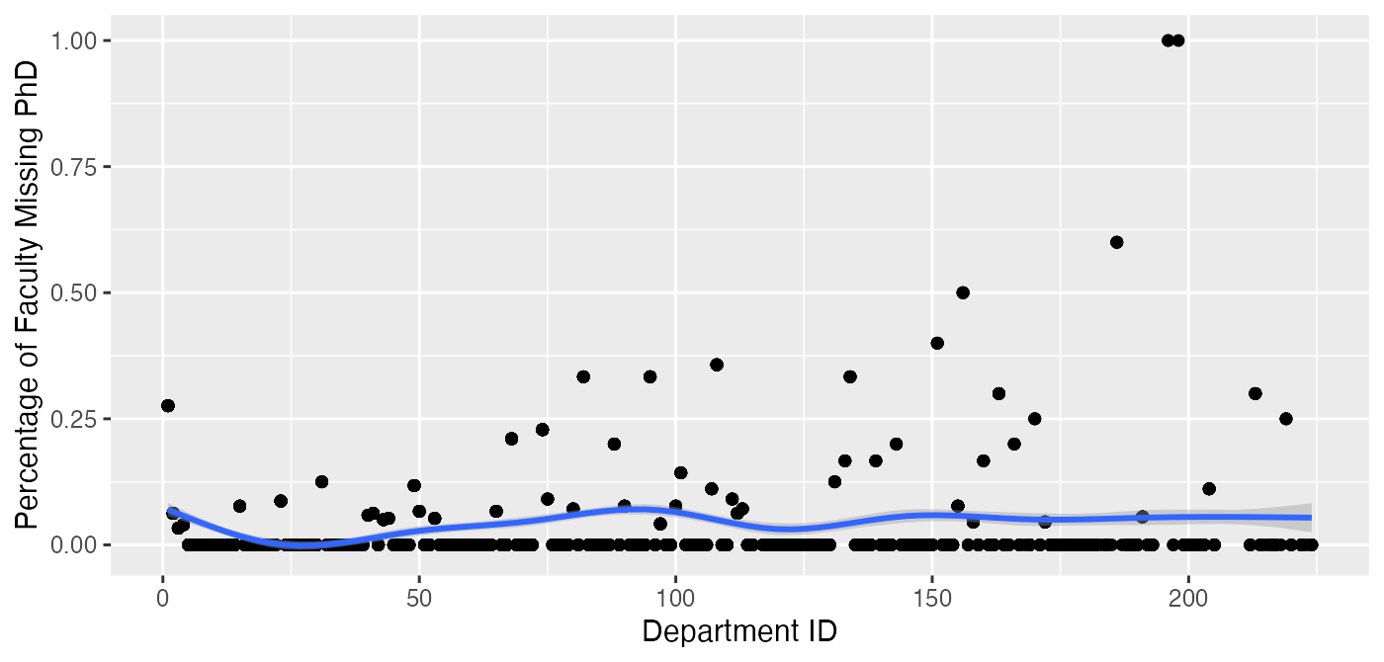
Notes: This figure shows the percentage of a department’s faculty that have missing information on PhD.

Figure A.2: Number of Faculty by Department, UTD Sample
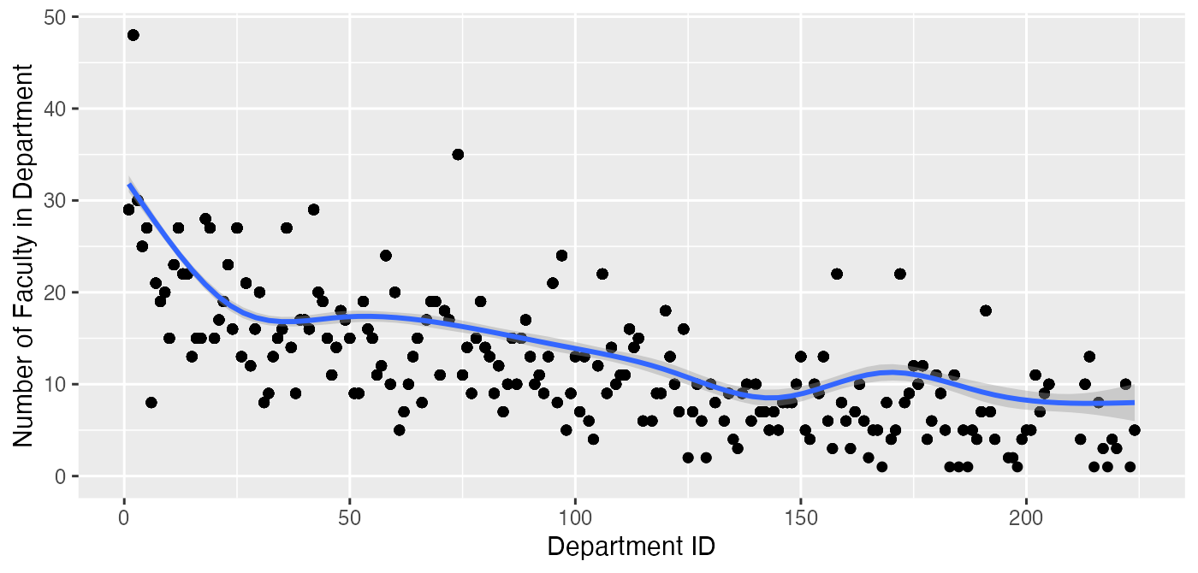
Notes: This figure displays the number of faculty by department, which is ordered according to ID (see Appendix Table A.1). Observations with missing PhD information are included.

Figure A.3: Average Rank of Department a PhD Programs’ Graduates Went To, by PhD Program, UTD Sample
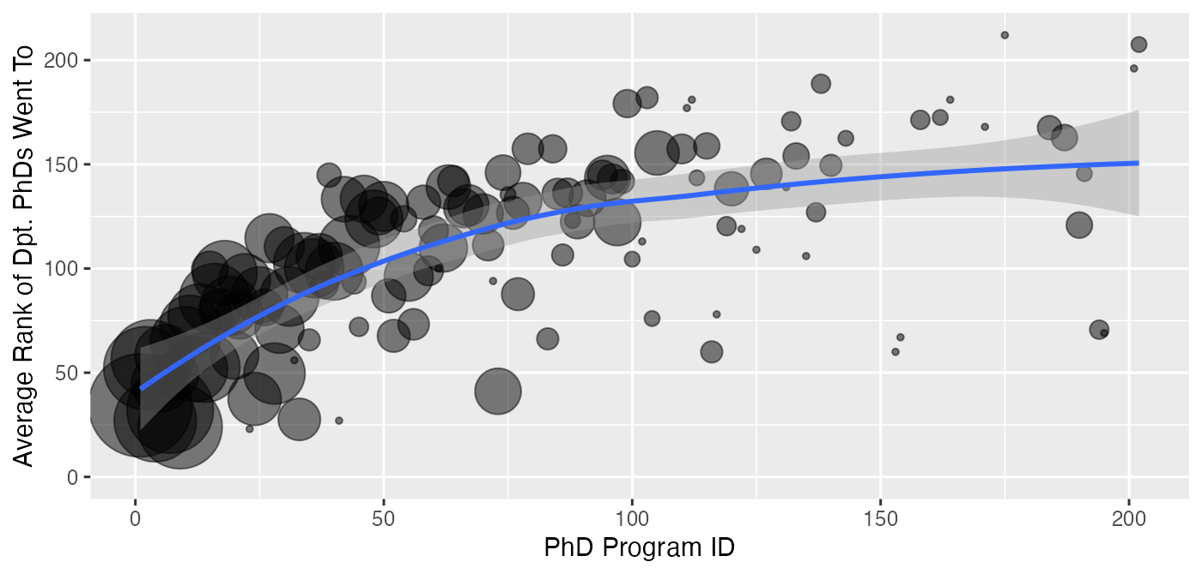
Notes: This figure displays the average department rank that graduates of a particular PhD program went to. PhD programs are ordered according to ID (see Appendix Table A.1), and are limited to those in Appendix Table A.1. PhD programs are weighted by number of graduates (in the sample).

Figure A.4: Percentage of a PhD Programs’ Graduates Who Went to Higher-ranked Department, by PhD Program, UTD Sample
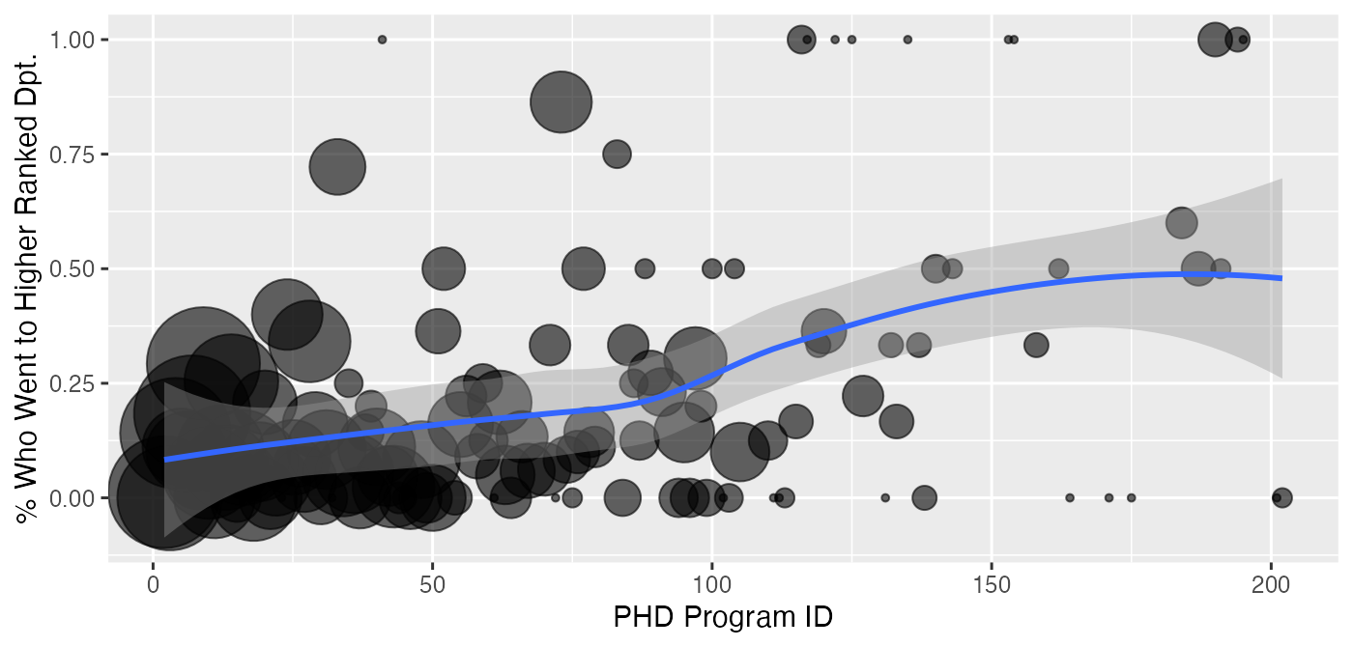
Notes: This figure displays the percentage of a PhD programs’ graduates (in the sample) who went to a higher-ranked department than their PhD program. PhD programs are ordered according to ID (see Appendix Table A.1), and are limited to those in Appendix Table A.1; those with a PhD from another institution (e.g., international) are excluded. Because by definition those who graduate from the top-ranked PhD programs cannot go to a department ranked higher than theirs, they are excluded. PhD programs are weighted by number of graduates (in the sample).

Figure A.5: Percentage of Department Faculty from Top X Ranked Phd Programs, by Department, UTD Sample
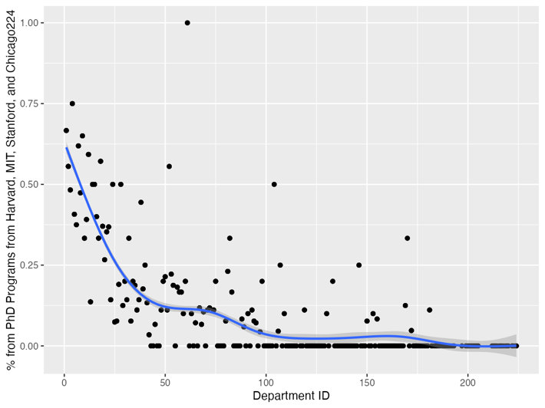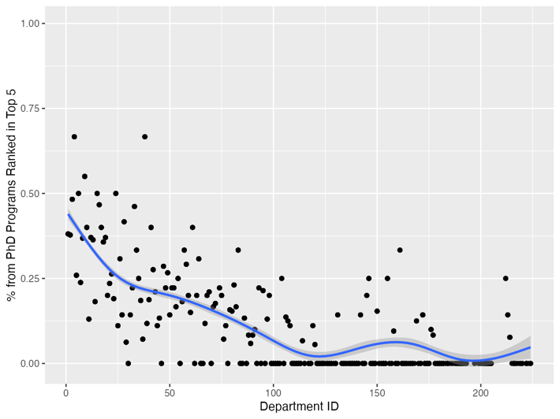
- Harvard, MIT, Stanford, and Chicago (B) 1-5
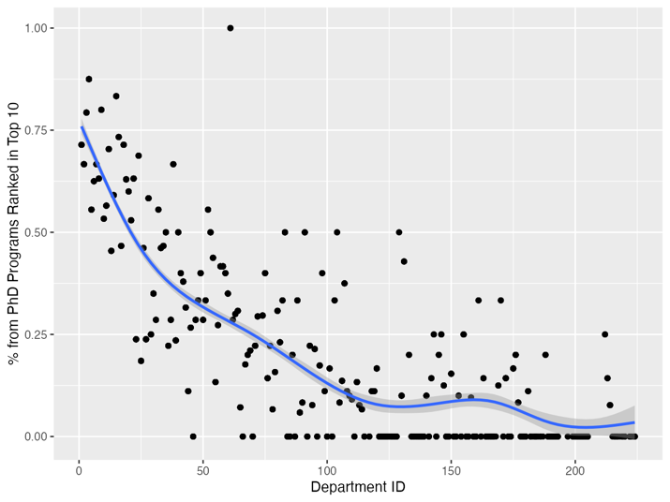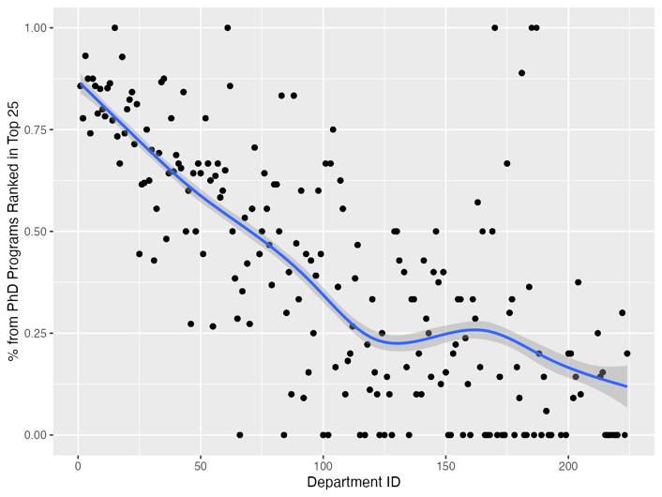
(C) 1-10 (D) 1-25
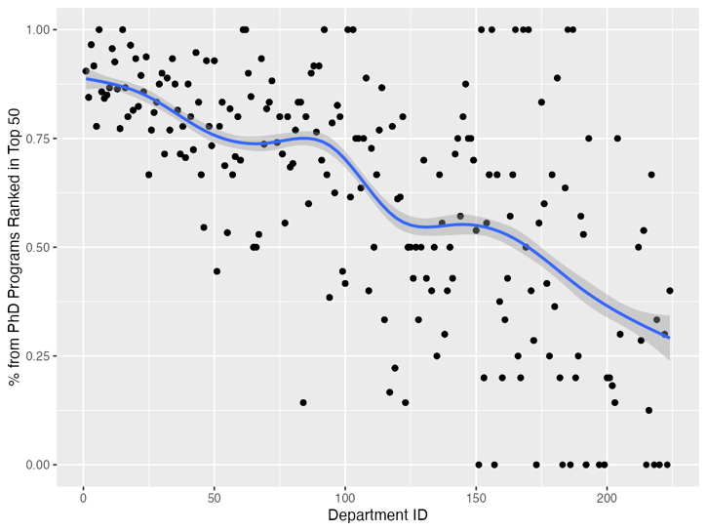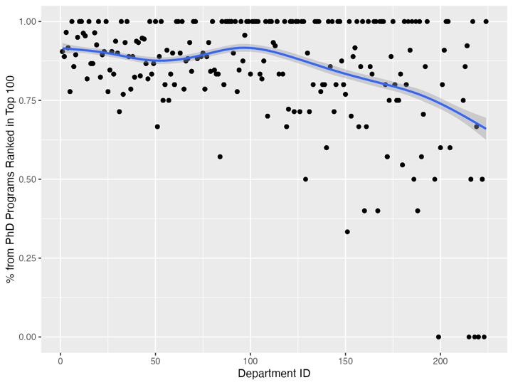
(E) 1-50 (F) 1-100
Notes: This graph shows the percentage of a department’s faculty from the departments indicated in the Panel title.

Figure A.6: Percent of Faculty Who Are Assistant, Associate, and Full Professors, by Department, UTD Sample
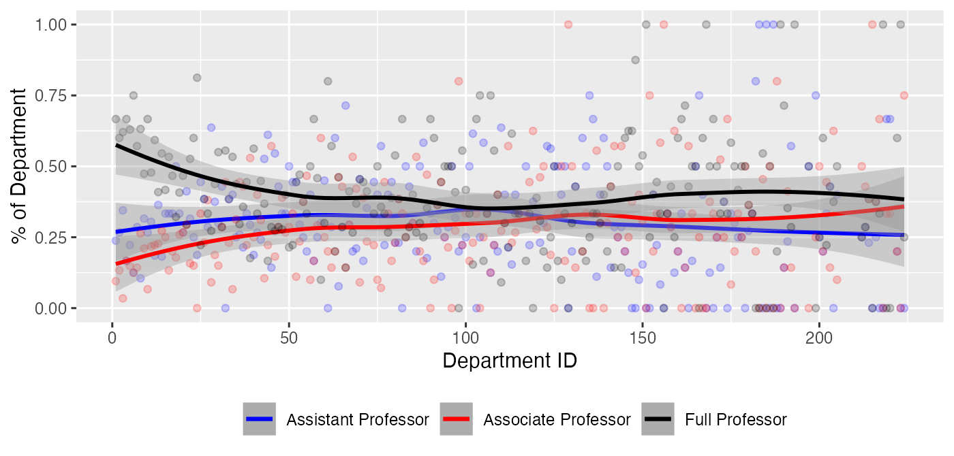
Notes: This figure displays the percentage of faculty who are an assistant professor (blue), associate professor (red), and full professor (black) by department, which is ordered according to ID (see Appendix Table A.1). Faculty with unknown rank are excluded.

Figure A.7: % of Department Faculty from Different Tiers of PhD Program, Dpts. 1-25 and 26-50, UTD Sample
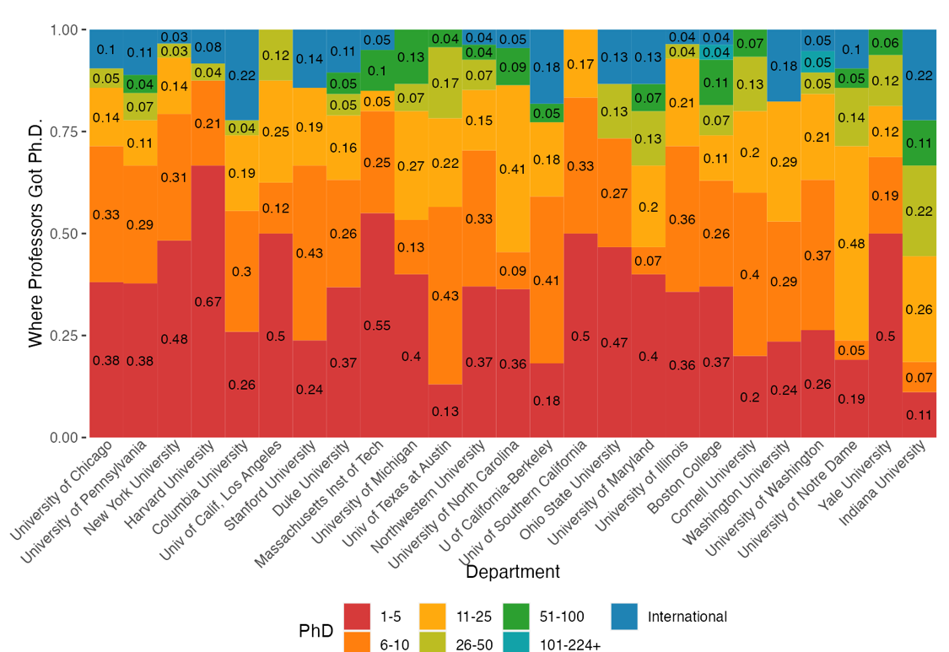
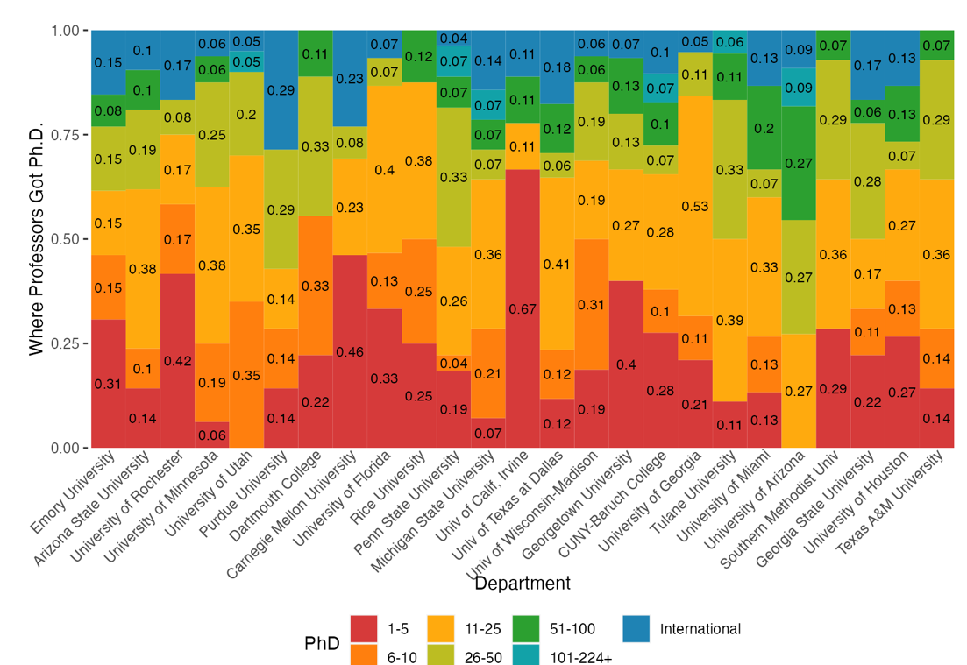

Notes: This figure displays the percentage of a department’s faculty that came from groupings of PhD program rankings. Each column is a department, and the colorings of the column represent the percentage of faculty that come from the particular PhD program group. The PhD category 101-224+ includes a small number of US observations that are not in the UTD rankings. Panel (a) shows department withs IDs 1-25, while Panel (b) shows departments with IDs 26-50.

Figure A.8: % of Department Faculty from Different Tiers of PhD Program, Dpts. 51-75 and 76-100, UTD Sample
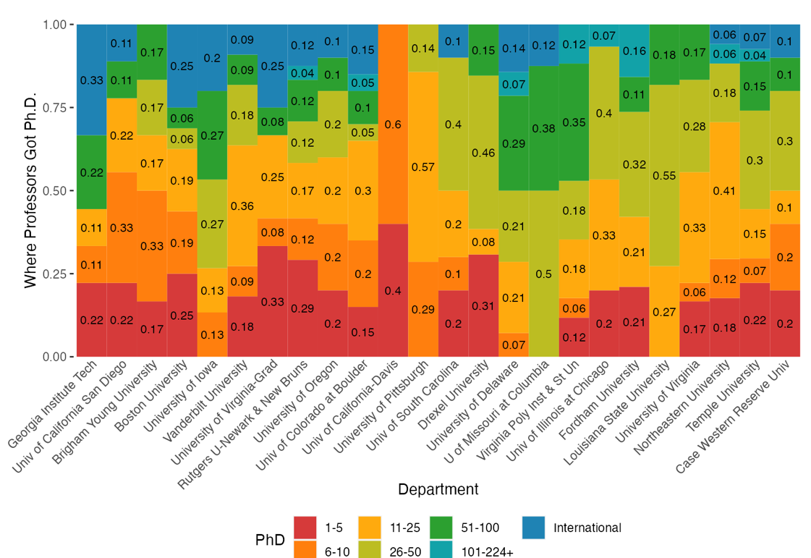
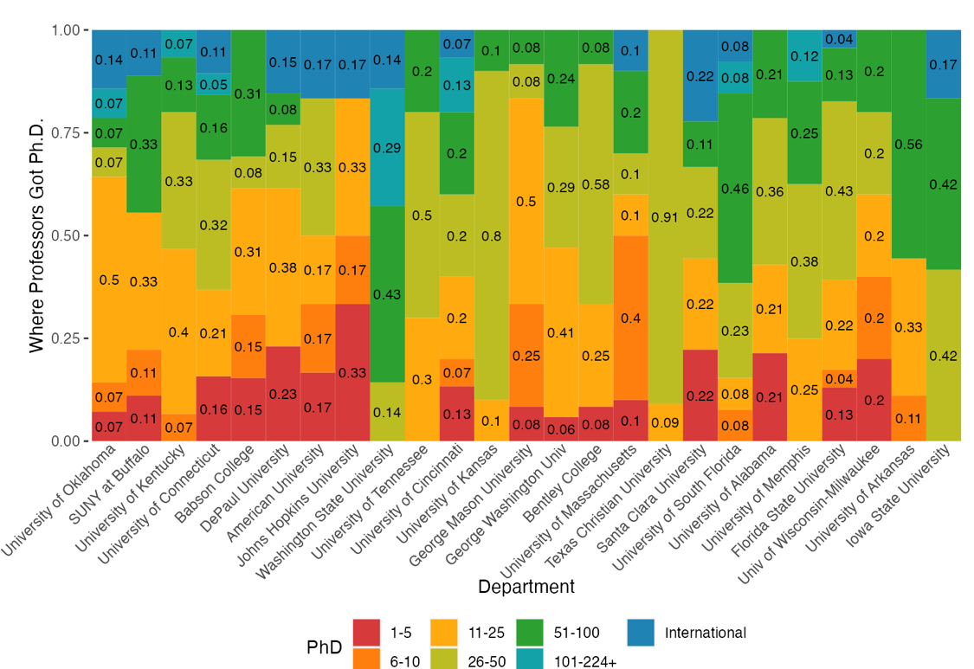
Notes: This figure displays the percentage of a department’s faculty that came from groupings of PhD program rankings. Each column is a department, and the colorings of the column represent the percentage of faculty that come from the particular PhD program group. The PhD category 101-224+ includes a small number of US observations that are not in the UTD rankings. Panel (a) shows department withs IDs 51-75, while Panel (b) shows departments with IDs 76-100.

Figure A.9: Average Rank of PhD Programs of a Department’s Faculty, by Department, UTD Sample
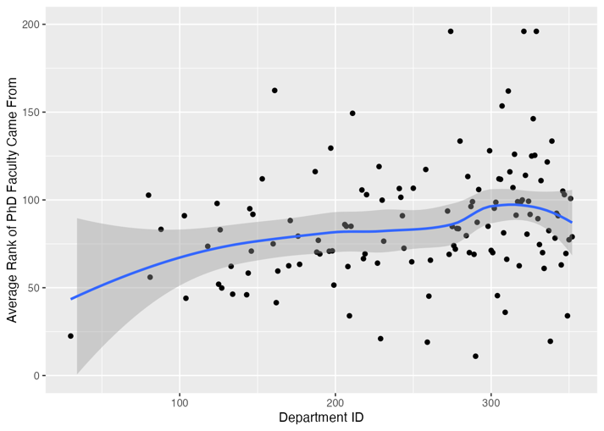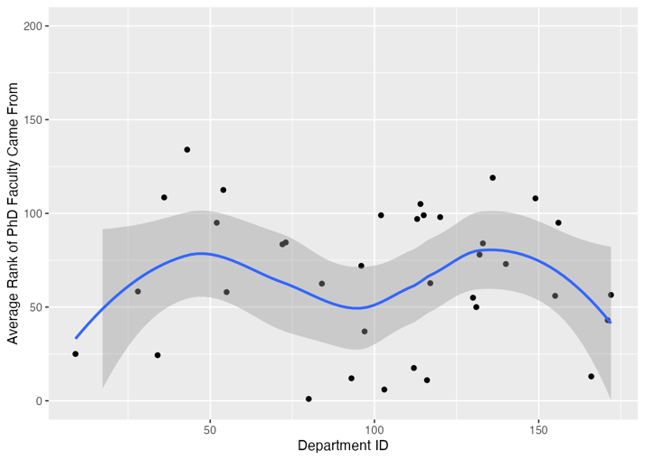
(A) National Universities (not in UTD) (B) Liberal Arts
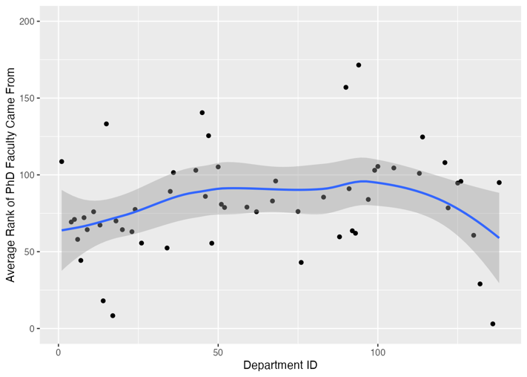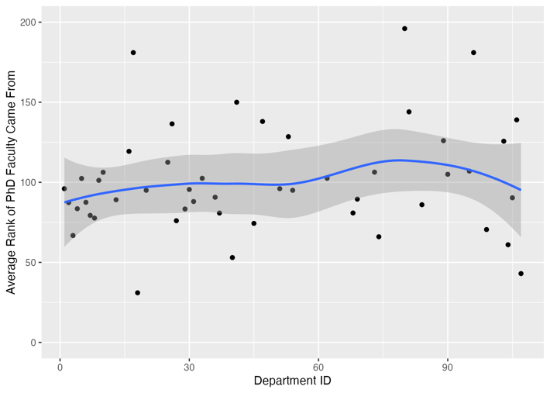
(C) Regional Universities North (D) Regional Universities South
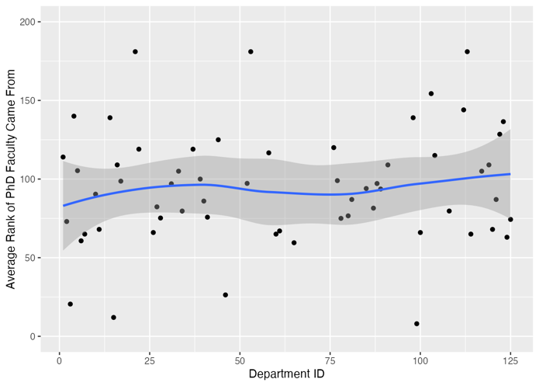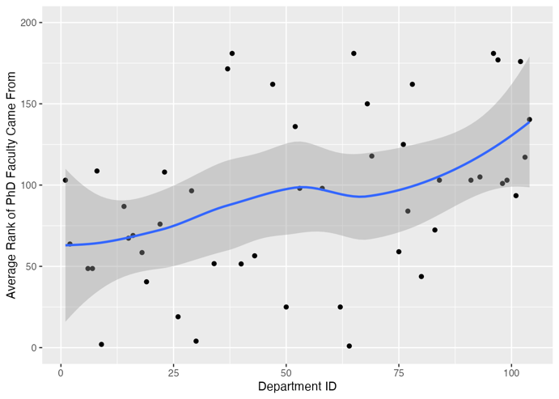
(E) Regional Universities Midwest (F) Regional Universities West

Notes: This figure displays, for a given department, the average rank of the PhD programs faculty members attended. Departments are ordered according to ID, which breaks ties of rank. Each ranking is specific to the sample. Unranked schools are not displayed. It is also restricted to those who went to ranked PhD programs.
Table A.1: UT Dallas Rankings and IDs
School | UTD | ID |  | School | UTD | ID
University of Chicago | 1 | 1 |  | University of Virginia-Grad | 57 | 57
University of Pennsylvania | 2 | 2 |  | Rutgers U-Newark & New Bruns | 58 | 58
New York University | 3 | 3 |  | University of Oregon | 59 | 59
Harvard University | 4 | 4 |  | Univ of Colorado at Boulder | 60 | 60
Columbia University | 5 | 5 |  | Univ of California-Davis | 61 | 61
Univ of Calif, Los Angeles | 6 | 6 |  | University of Pittsburgh | 62 | 62
Stanford University | 7 | 7 |  | Univ of South Carolina | 63 | 63
Duke University | 8 | 8 |  | Drexel University | 64 | 64
Massachusetts Inst of Tech | 9 | 9 |  | University of Delaware | 65 | 65
University of Michigan | 10 | 10 |  | U of Missouri at Columbia | 66 | 66
Univ of Texas at Austin | 11 | 11 |  | Virginia Poly Inst & St Un | 67 | 67
Northwestern University | 12 | 12 |  | Univ of Illinois at Chicago | 68 | 68
University of North Carolina | 13 | 13 |  | Fordham University | 69 | 69
U of California-Berkeley | 14 | 14 |  | Louisiana State University | 70 | 70
Univ of Southern California | 15 | 15 |  | University of Virginia | 71 | 71
Ohio State University | 16 | 16 |  | Northeastern University | 72 | 72
University of Maryland | 17 | 17 |  | Princeton University | 73 | X
University of Illinois | 18 | 18 |  | Temple University | 74 | 74
Boston College | 19 | 19 |  | Case Western Reserve Univ | 75 | 75
Cornell University | 20 | 20 |  | University of Oklahoma | 76 | 76
Washington University | 21 | 21 |  | SUNY at Buffalo | 77 | 77
University of Washington | 22 | 22 |  | University of Kentucky | 78 | 78
University of Notre Dame | 23 | 23 |  | University of Connecticut | 79 | 79
Yale University | 24 | 24 |  | Babson College | 80 | 80
Indiana University | 25 | 25 |  | DePaul University | 81 | 81
Emory University | 26 | 26 |  | American University | 82 | 82
Arizona State University | 27 | 27 |  | Johns Hopkins University | 83 | 83
University of Rochester | 28 | 28 |  | Washington State University | 84 | 84
University of Minnesota | 29 | 29 |  | University of Tennessee | 85 | 85
University of Utah | 30 | 30 |  | University of Cincinnati | 86 | 86
Purdue University | 31 | 31 |  | University of Kansas | 87 | 87
Dartmouth College | 32 | 32 |  | George Mason University | 88 | 88
Carnegie Mellon University | 33 | 33 |  | George Washington Univ | 88 | 89
University of Florida | 34 | 34 |  | Bentley College | 90 | 90
Rice University | 35 | 35 |  | University of Massachusetts | 91 | 91
Penn State University | 36 | 36 |  | Texas Christian University | 92 | 92
Michigan State University | 37 | 37 |  | Santa Clara University | 93 | 93
Univ of Calif, Irvine | 38 | 38 |  | University of South Florida | 94 | 94
Univ of Texas at Dallas | 39 | 39 |  | University of Alabama | 95 | 95
Univ of Wisconsin-Madison | 40 | 40 |  | University of Memphis | 96 | 96
Georgetown University | 41 | 41 |  | Florida State University | 97 | 97
CUNY-Baruch College | 42 | 42 |  | Univ of Wisconsin-Milwaukee | 98 | 98
University of Georgia | 43 | 43 |  | University of Arkansas | 99 | 99
Tulane University | 44 | 44 |  | Iowa State University | 100 | 100
University of Miami | 45 | 45 |  | Univ of Calif, Riverside | 101 | 101
University of Arizona | 46 | 46 |  | Clemson University | 102 | 102
Southern Methodist Univ | 47 | 47 |  | Un of Texas at San Antonio | 103 | 103
Georgia State University | 48 | 48 |  | Brandeis University | 104 | 104
University of Houston | 49 | 49 |  | Texas Tech University | 105 | 105
Texas A&M University | 50 | 50 |  | Calif State Univ, Fullerton | 106 | 106
Georgia Institute Tech | 51 | 51 |  | College of William & Mary | 107 | 107
Univ of California San Diego | 52 | 52 |  | San Diego State University | 108 | 108
Brigham Young University | 53 | 53 |  | Loyola Marymount Univ | 109 | 109
Boston University | 54 | 54 |  | University of Nebraska | 109 | 110
University of Iowa | 55 | 55 |  | Lehigh University | 111 | 111
Vanderbilt University | 56 | 56 |  | Univ of Central Florida | 112 | 112

Table A.1: UT Dallas Rankings and IDs (Continued)
School | UTD | ID |  | School | UTD | ID
North Carolina at Charlotte | 113 | 113 |  | Chapman University | 168 | 169
Baylor University | 114 | 114 |  | Claremont McKenna College | 168 | 170
SUNY at Binghamton | 115 | 115 |  | Montana State University | 168 | 171
California Institute of Technology | 116 | X |  | St. John’s University | 168 | 172
Kansas State University | 117 | 117 |  | Univ of Texas at El Paso | 168 | 173
North Carolina State Univ | 117 | 118 |  | University of St. Thomas-MN | 168 | 174
Kent State University | 119 | 119 |  | Univ of Hawaii at Manoa | 175 | 175
Syracuse University | 119 | 120 |  | Old Dominion University | 176 | 176
Villanova University | 119 | 121 |  | Colorado State University | 177 | 177
Auburn University | 122 | 122 |  | North Carolina at Greensboro | 177 | 178
Ohio University | 123 | 123 |  | Univ of Michigan-Dearborn | 177 | 179
Miami University | 124 | 124 |  | University of San Diego | 177 | 180
Southern Illinois Univ | 125 | 125 |  | Calif Polytechnic State U | 181 | 181
Marquette University | 126 | 126 |  | Cleveland State University | 181 | 182
University of Mississippi | 126 | 127 |  | Eastern Kentucky University | 181 | 183
Rochester Inst of Technology | 128 | 128 |  | Florida Atlantic Univ | 181 | 184
Quinnipiac University | 129 | 129 |  | Gustavus Adolphus College | 181 | 185
Suffolk University | 129 | 130 |  | SUNY College at Oswego | 181 | 186
University of Rhode Island | 129 | 131 |  | U of Calif, Santa Barbara | 181 | 187
Claremont Graduate University | 129 | X |  | University of Baltimore | 181 | 188
Rensselaer Poly Institute | 133 | 133 |  | University of Montana | 181 | 189
U Massachusetts Boston | 134 | 134 |  | University of New Orleans | 181 | 190
University of Wyoming | 134 | 135 |  | University of North Texas | 181 | 191
Wake Forest University | 134 | 136 |  | University of Northern Iowa | 181 | 192
Wayne State University | 134 | 137 |  | University of West Georgia | 181 | 193
West Virginia University | 134 | 138 |  | Naval Postgraduate School | 181 | X
Northern Illinois Univ | 139 | 139 |  | Brown University | 181 | X
Oklahoma State University | 139 | 140 |  | Georgia Col & State Univ | 196 | 196
Oregon State University | 139 | 141 |  | Michigan Technological Univ | 196 | 197
Portland State University | 139 | 142 |  | New Jersey City University | 196 | 198
Saint Louis University | 139 | 143 |  | Penn State Univ-Erie | 196 | 199
Utah State University | 139 | 144 |  | Roger Williams University | 196 | 200
Seton Hall University | 145 | 145 |  | Texas A&M Intl University | 196 | 201
Indiana Univ - Indianapolis | 146 | 146 |  | U of Massachusetts at Lowell | 196 | 202
Univ of Colorado at Denver | 146 | 147 |  | University of Louisville | 196 | 203
Kennesaw State University | 148 | 148 |  | Virginia Commonwealth Univ | 196 | 204
Loyola University Chicago | 148 | 149 |  | Western Michigan University | 196 | 205
Calif State Univ, Northridge | 150 | 150 |  | Arizona State University West | 196 | X
Creighton University | 150 | 151 |  | SUNY Brockport | 196 | X
Oakland University | 150 | 152 |  | Worcester Polytechnic Institute | 196 | X
Stony Brook University | 150 | 153 |  | Lehman College | 196 | X
University of Richmond | 150 | 154 |  | Queens College, CUNY | 196 | X
Pace University | 155 | 155 |  | Williams College | 196 | X
Wichita State University | 155 | 156 |  | Calif State U - San Marcos | 212 | 212
Bowling Green State Univ | 157 | 157 |  | Fairfield University | 212 | 213
Florida International Univ | 157 | 158 |  | Hofstra University | 212 | 214
Towson University | 157 | 159 |  | Indiana Univ Southeast | 212 | 215
U Missouri–St. Louis | 157 | 160 |  | Nova Southeastern Univ | 212 | 216
Yeshiva University | 157 | 161 |  | Thunderbird Sch Global Mgt | 212 | 217
Mississippi State Univ | 162 | 162 |  | University of Hawaii at Hilo | 212 | 218
San Francisco State Univ | 162 | 163 |  | New Jersey Institute of Tech | 219 | 219
U of Texas at Arlington | 162 | 164 |  | Winthrop University | 219 | 220
Pepperdine University | 165 | 165 |  | University of California at Merced | 219 | X
Rutgers University-Camden | 165 | 166 |  | Calif State Poly U-Pomona | 222 | 222
Gonzaga University | 167 | 167 |  | Capital University | 222 | 223
Calif State Univ, Chico | 168 | 168 |  | Rider University | 222 | 224

Notes: This table show the UT Dallas rankings of economics departments. There are many cases in which departments are tied; as such, we create a unique ID in order to distinguish tied schools, which are arranged alphabetically. Departments in the UTD rankings data, but not in the directory has an X for ID.

Table A.2: Departments with Highest Concentration of Faculty from PhD Programs, UTD Sample
PhD | Department | Percent
Harvard University | Harvard University | 42
Harvard University | Yale University | 38
University of Chicago | Univ of Calif, Los Angeles | 38
U of California-Berkeley | Calif Polytechnic State U | 33
University of Chicago | University of Rochester | 33
University of Rochester | Dartmouth College | 33
Penn State University | Drexel University | 31
University of Pennsylvania | Carnegie Mellon University | 31
Boston College | Suffolk University | 30
Texas Tech University | Oklahoma State University | 30
U of Calif, Santa Barbara | Calif State Poly U-Pomona | 30
University of Chicago | Massachusetts Inst of Tech | 30
University of Michigan | University of Massachusetts | 30
Massachusetts Inst of Tech | University of Illinois | 29
Ohio State University | University of Pittsburgh | 29
U of Missouri at Columbia | University of Northern Iowa | 29
University of Alabama | Mississippi State Univ | 29
University of Alabama | University of Louisville | 29
University of Arizona | Utah State University | 29
University of Connecticut | Fairfield University | 29
University of Michigan | University of Pittsburgh | 29
University of Mississippi | Utah State University | 29
University of Washington | Oregon State University | 29
Massachusetts Inst of Tech | Ohio State University | 27
New York University | Georgetown University | 27
University of Chicago | Duke University | 26
Boston College | College of William & Mary | 25
Georgia State University | Kennesaw State University | 25
Purdue University | Indiana Univ - Indianapolis | 25
U of California-Berkeley | Univ of Calif, Los Angeles | 25
University of Alabama | Univ of Texas at El Paso | 25
University of Chicago | Indiana Univ - Indianapolis | 25
University of Chicago | Univ of Southern California | 25
University of Illinois | Chapman University | 25
University of Illinois | University of Memphis | 25
University of Kansas | Towson University | 25
University of Chicago | University of Pennsylvania | 24
Harvard University | University of Chicago | 24
Massachusetts Inst of Tech | University of Chicago | 24
Stanford University | Stanford University | 24
CUNY-Baruch College | Hofstra University | 23
University of Arizona | Clemson University | 23
Harvard University | Univ of Calif, Irvine | 22
Harvard University | Univ of California San Diego | 22
Ohio State University | San Diego State University | 22
Stanford University | Univ of California San Diego | 22
University of Chicago | Univ of Calif, Irvine | 22
University of Florida | North Carolina State Univ | 22
University of Minnesota | University of St. Thomas-MN | 22
University of Pittsburgh | Georgia Institute Tech | 22
University of Pittsburgh | North Carolina State Univ | 22
University of Washington | San Diego State University | 22

Notes: This table displays the instances where at least 22% of a department’s faculty comes from a particular PhD program. Departments with fewer than seven faculty members are not considered, which excludes many departments. Only PhD programs included in Appendix Table A.1 are considered.

Competing Interests Statement
The authors have no competing interests to declare.

We use “department” to refer to finance faculty’s current job and “program” to refer to where they received their PhD.
See http://www.jrhasselback.com/FacDir/F2019-2020%20(02-08-2020).pdf.
A related explanation is statistical discrimination—a hiring department may use the ranking of a candidate’s PhD program for a proxy of expected productivity.
We refer to a university’s faculty as a department, even if that university does not have a department of faculty per se. For example, it is common for finance faculty to be housed in a school or college of business or in a joint department of finance and one or more subjects, such as a department of economics and finance.
Some degree of measurement error may exist given 1) the monumental task of gathering data on so many departments; 2) not all departments responding to the verification inquiry; and 3) not all departments keeping their listings up to date. With the exception of correcting one error regarding one person’s PhD department, we use the directory data as is. We do not fill in the relatively small number of instances where individuals are missing their PhD department; see also section 2.4. We also did not attempt to fill in instances that appear to have fewer faculty in the directory than they are likely to have had when the data were collected, such as UCLA.
In general, we refer to the highest degree as PhD, though in some cases it is another degree, such as a JD or MS. The university is referenced in shorthand, such as “Harvard.” As such, we make assumptions about which university it corresponds to in cases of ambiguity.
In particular, we exclude instructional faculty such as professors of practice, adjunct professors, instructors and lecturers, affiliated faculty, research faculty, teaching faculty, clinical professors, visiting professors, emeritus professors, and the like.
Specifically, a solo-authored paper contributes a score of 1, and a joint-authored paper contributes a score of x/n, where x is the number of faculty in the departments and n is the number of coauthors. If an author lists multiple affiliations, each of the m affiliations gets 1/m of the credit.
We also combine several institutions that are included twice, for instance if they changed names. The exception is that University of Virginia appears twice as two separate units. We do not combine these in the rankings. We assign PhDs from the University of Virginia to the ranking of the higher ranked of the two. Both departments appear in the FIRE data.
Not all of the 210 departments that appear in the UTD rankings offer a PhD. When ranking PhD programs, we use the same rankings from 1 to 224 and do not exclude universities without a PhD program.
We also do not have information on the field of PhD (only the university), so we are unable to make this distinction.
See Appendix Figure A.2 for the number of faculty by department for the UTD sample, after sample restrictions. Higher-ranked departments tend to have more faculty.
Specifically, the rank for the UTD sample corresponds to the UTD rank (shown in Appendix Table A.1), and the ranks for the USNWR samples correspond to the USNWR rank specific to that sample. For example, the regional universities west rank is obtained from the USNWR regional university west ranking.
One reason that it is imperfect is that there is survivorship bias with full professors. Full professors have also had a much longer time to change departments. Another is that department rankings change over time.
See Appendix Figure A.6 for the fraction of the department that is Assistant, Associate, and Full professors. The median professor is a full professor, with full professors making up a larger share of top-ranked departments.
The relative heights of the faculty department sample categories should not be interpreted as the total number of finance professors in these categories as not all schools in these categories appear in the directory.
For example, Florida State University in Panel (a) means 24 professors in National Universities listed in USNWR rankings received their PhD at Florida State University.
For these plots, we exclude one school that is now closed and not combined with another school and do not display Hawaii. We consider Baruch and all CUNY as Graduate Center; in earlier analyses, we assign them all the PhD rank of Baruch. We obtain the geocoded data from IPEDS (U.S. Department of Education, 2019).
Each of these fields uses the respective U.S. News & World Report Graduate School Rankings: business (USNWR, 2011a), computer science (USNWR, 2010), history (USNWR, 2009), law (USNWR, 2018), and economics (USNWR, 2017).
Another issue is that the rankings do not capture all universities, and the number of ranked universities varies by field; thus more universities are eligible to be ranked in Panels B and D for fields with more ranked universities. We also use different rankings for finance (UTD) than for the other fields (USNWR); one consequence is that the UTD rankings are not selected on having a graduate program and thus may include some universities without one. Panels B and D are primarily based on the number of PhDs produced, which should make finance’s rankings more comparable to those of the other fields. The number of individuals in the sample for history varies slightly from that reported in Clauset, Arbesman, and Larremore (2015).
For a university to be considered in this new ranking, it must be ranked (and not just appear) in UTD (finance) or USWNR (other fields). In the ranking, we break ties by the number of PhDs produced by the university who are teaching at universities with rankings 1-25, further ties by the number of PhDs produced by the university who are teaching at universities with rankings 26-50, and further ties randomly. While this is different than the tie-breaking method used earlier in the paper, the ranks for finance are nearly identical, and all groups (1-5, 1-10, 1-25, and 1-50) are exactly the same.
Law has data for faculty teaching at the top 25 (USNWR ranked universities) plus only a handful of additional universities; we thus re-weight law in the final column (Top 50 from Top 50) of each panel. In particular, we first calculate the statistic separately for faculty in universities ranked 1-25 and for those in universities ranked 26-50. We then take the average of these numbers, weighting by the average number of faculty in (observed) universities in each group. We perform a similar procedure for Panels B and D for finance, which is missing one university when using the new ranking. Finally, for both finance and law, we re-weight the Top 25 from Top 25 column of Panels B and D using 1-12 and 13-25 groups, also adjusting for the fact that the first group has 12 departments and the second has 13. After doing this, results are the same. The exceptions are that law in the final column, Panels B and D, is 1 percentage point (.01 in the table) lower; law in the final column, Panel C, is 2 percentage points lower; and finance in the second-to-last-column, Panel D, is 1 percentage point lower than if we had not reweighted.
We also consider English (Colander and Zhuo, 2015), but we do not have access to the underlying data and so rely on the results presented in their Table 3. The authors use 2011 USNWR English graduate rankings (USNWR, 2011b). The tiers the authors use (rank 1-6; rank 7-28; rank 29-62; and rank 63+) are different than the ones we construct, but we can still make rough comparisons. We note that they apparently use data on only a sample of departments within these tiers. 57% of English faculty teaching at top 6 department received their PhD from one of the top 6 programs. This would rank right in the middle of the fields in Column 1 of our Table 5 Panel A (fraction of top 5 from the top 5). Based on the numbers in their paper, we also compute the percentage of faculty at the top 28 from the top 28, excluding those with non-PhDs from the calculation because rank is not reported for these. They present results separately by department bin, necessitating a calculation to obtain the statistic we desire; to obtain this, we weight by number of departments represented by the bin, assuming that the size of faculty is constant across bins (which is supported by the authors in Appendix B). We find that 84% of the top 28 came from the top 28. This would rank English as the fourth least mobile field, compared to the fields in Column 3 of Table 5 Panel A (fraction of top 25 from the top 25). We perform a similar calculation for the top 62 departments (weighting the top 28 departments higher as the authors indicate the faculty size is on average smaller for departments ranked 29-62, though this turns out not to matter). 91% of the top 62 English faculty come from the top 62. This would rank English as the second least mobile field, compared to the fields in Column 4 of Table A (fraction of top 50 from the top 50).
In particular, we break ties by the number of PhDs produced by the university who are teaching at universities with rankings 26-50, break further ties with the UTD or USNWR rankings, and further ties randomly.
There are only 96 ranked departments in economics; we expand this to 100 based on PhDs produced.

